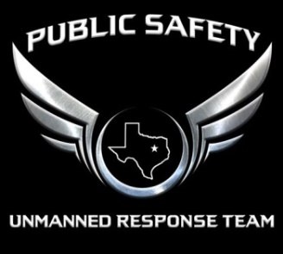
PSURT UAS Visual Observer Checklist
- For detailed information about the qualification levels, see the PSURT UAS Program Guide.
- For detailed information about the course and testing procedures, see the relevant PSURT Training Documents.
TESTING INFORMATION
TEST DATE |  | TEST LOCATION

VO INFORMATION
VO NAME |  | DEPARTMENT / AGENCY
TITLE |  | EMAIL

VO COURSE TOPICS | PASS
UAS OPERATIONS
DEFINITIONS AND ROLES
UNDERSTANDING AIRSPACE, NOTAM’s, and TFR’s
NIGHT OPERATIONS
HOW THE EYE WORKS
SPATIAL DISORIENTATION AND VISUAL ILLUSIONS
IMPROVING YOUR NIGHT VISION
THE WHO, WHAT, AND WHEN OF BEING A VO
FINAL QUIZ

INSTRUCTOR INFORMATION
INSTRUCTOR NAME |  | DEPARTMENT / AGENCY
INSTRUCTOR TITLE |  | INSTRUCTOR EMAIL

_______________________________ ______________________________ ________________
INSTRUCTOR SIGNATURE VO SIGNATURE DATE

