PSURT UAS Visual Observer Course

___________________________________
Instructor Guide

The vision of the participating departments and agencies is to create baselines for emerging technologies and standards for integrating them into existing emergency response, establish coordination between private and public, local and regional stakeholders to bridge the gaps in resource and capability sharing, and increase situational awareness and incident command decisions at emergency scenes.
This document establishes standard guidelines for training UAS Visual Observers for departmental as well as multi-agency missions.

Contents
Introduction 1
Equipment 1
Welcome and Overview 2
UAS Operations 3
Part 107, COA, and SGI 9
Understanding Airspace, NOTAM’s and TFR’s 13
Night Operations 15
How the Eye Works 16
Limitations of Cone Cells (Our Day Camera) 16
Limitations of Rod Cells (Our Night Camera) 17
Mesopic Vision 17
Spatial Disorientation and Visual Illusions 19
Improving Your Night Vision 21
The Who, What, and When of Being a VO 22
Procedure for Scanning the Sky 23
Appendix A: Form Examples 24
PSURT UAS Visual Observer Checklist 24
PSURT UAS Visual Observer Certification Form 25
PSURT UAS RPIC/VO Night Mission Pre-Flight Quiz 26
PSURT UAS Course Evaluation Form 27

Introduction
This course is for public safety personnel who want to be trained as UAS Visual Observers.
Instructors should be knowledgeable about the types of missions to which law enforcement and emergency management personnel respond. It is recommended that, at a minimum, instructors have their FAA Part 107 license and several hours of hands-on flight experience on multiple small unmanned aircraft.
Thoroughly read through the Instructor Guide. Throughout the guide, there are instructor notes in gray boxes that contain additional information and tips for you. The student guides have the same format as the instructor guide but without the instructor notes.
While it is recommended that you teach all of the included material, you should add any additional information that is relevant to your community / department / agency.

Equipment
You will need:
- A computer with PowerPoint and sound
- Student guides

Welcome and Overview
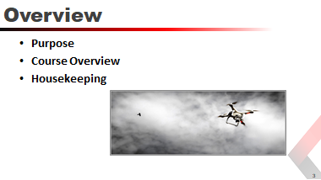
Purpose
The purpose of the PSURT UAS Visual Observer (VO) course is to train you to be a second set of eyes and ears to monitor the airspace in which the UAS is flying for any potential collision hazard, and to maintain awareness of the position of the UAS at all times, in order to support the RPIC. The VO is a key component in airspace safety.
This course does not certify you as a UAS pilot (RPIC).
Course Overview
This course covers UAS Operations, FAA rules and regulations, airspace and related documentation, night operations, and the who, what, and when of being a VO.
Housekeeping
Cover any needed housekeeping topics, such as breaks and directions to the restroom.
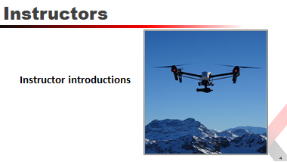
Instructor Note: Mention that the instructors are all sUAS FAA Part 107 certified pilots. Have each instructor give a brief introduction.

UAS Operations
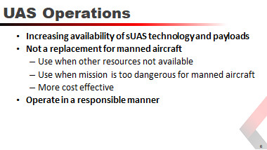
The increasing availability of low-cost small unmanned aircraft systems ("sUAS") technology allied with image processing applications, real-time video and various sensor payloads, offer an opportunity to collect forensic-quality scene information, provide infrastructure inspections and damage assessments, speed up incident clearance, assist in search and rescue, improve fire observation, and reduce the exposure of law enforcement officers, emergency responders and the public to hazardous conditions.
sUAS are not a replacement for manned aircraft, however, they are an excellent tool to be used when those resources are unavailable, if the mission is too dangerous for manned aircraft, or when deemed more cost effective than conventional air assets.
UAS assets shall be operated in a responsible manner consistent with Department policy, Texas State laws, and federal rules and regulations; ensuring that the privacy rights of the people in the State of Texas are respected.
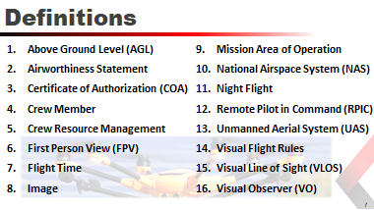
Above Ground Level (AGL) | The measured altitude of an aircraft or UAS above the ground that it is flying over.
Airworthiness Statement | The Airworthiness of the UAS is self-certified by the RPIC through a preflight inspection prior to flight.
Certificate of Authorization (COA) | COA is an authorization issued by the Federal Aviation  Administration (FAA) to a public operator for a UAS. After a complete application is submitted, the FAA conducts an operational and technical review. If necessary, provisions or limitations may be imposed as part of the approval to ensure the UAS can operate safely with other airspace users.
Crewmember | A person assigned to perform duty while an aircraft is operating.
Crew Resource Management (CRM) | The effective use of all available resources including human, hardware, and information resources and coordination in the use of those resources by the RPIC and Visual Observer.
First Person View (FPV) | The RPIC is observing the flight solely through the UAV’s camera.
Flight time | Remote piloting flight time commences when an aircraft moves under its own power for the purpose of flight and ends when the aircraft comes to rest after landing.
Image | Means any capturing of sound waves, thermal, infrared, ultraviolet, visible light, or other electromagnetic waves, odor, or other conditions existing on or about real property in this state or an individual located on that property. Imagery may include data about people, organizations, events, incidents, or objects as well as metadata.
Mission Area of Operations (AOR) | A defined perimeter/parameters to be determined based on the scope and type of the operation and a defined operational ceiling at or below 400 feet above the ground. The altitude of the small unmanned aircraft cannot be higher than 400 feet above the ground, unless the small unmanned aircraft is flown within a 400 foot radius of a structure and does not fly higher than 400 feet above the structure’s immediate uppermost limit.
National Airspace System (NAS) | Airspace inside the continental United States. It is further defined through air navigation facilities, equipment and services, airports or landing areas; aeronautical rules, regulations and procedures. There are two types of airspace within the NAS, controlled and uncontrolled. Operation of a UAS in controlled airspace adds another layer of responsibilities and requirements that must be met to operate the UAS.
Night Flight | Flight of a UAS that occurs between the hours of one half hour after sunset and one half hour before sunrise. The time of sunset and sunrise are determined by the National Oceanic and Atmospheric Administration (NOAA), but 14 CFR Part 107 will allow small UAS operations to be conducted during civil twilight if the small unmanned aircraft has lighted anti-collision lighting visible for at least 3 statute miles. The nighttime-operations prohibition in this rule is waivable through the FAA for Part 107 or as an addendum to approved certificate of waiver to the COA.
Remote Pilot in Command (RPIC) | The RPIC is the person directly responsible for and is the final authority as to the operation of the UAS. A PSURT RPIC has an FAA Part 107 Remote Pilot certificate and has completed at least the PSURT Level 1 Course.
Unmanned Aerial System / Vehicle (UAS/UAV) | UAS is the unmanned aircraft system and all of the associated support equipment, control station, data links, telemetry, communications, and navigation equipment, etc., necessary to operate the unmanned aircraft. The aircraft’s flight is controlled either autonomously by hardware within the UAS or under the remote control of a RPIC on the ground or in another ground vehicle. For purposes of this program the 14 CFR Part 107 compliant UAS shall weigh less than 55 pounds fully loaded. Maximum groundspeed is limited to 100 mph (87 knots).
Visual Flight Rules (VFR) | All flights with the UAS shall be conducted under VFR conditions and at an altitude below 400’ AGL. VFR is established as a 3 mile visibility and a cloud ceiling of 1,000 feet for day operations and 5 mile visibility with a cloud ceiling of 2,000 feet for night operations.
Visual Line of Sight (VLOS) | The RPIC and/or the Visual Observer can see, unaided, the UAS under their control during flight.
Visual Observer (VO) | The VO is a crew member for a flight mission who serves as a second set of eyes and monitors the UAS in flight in order to support the RPIC.  The VO is a key component in airspace safety.
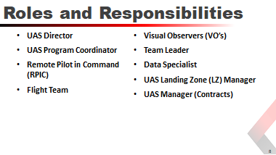
UAS Director | Resolve conflicts or disputes that might arise related to policy or mission within their division.  Establish protocols to prevent violations of policy, law, and public privacy.  Control the dissemination of any information produced by the divisions UAS team.  Designate the UAS Program Coordinator.  Shall be ultimately responsible for his/her divisions reporting requirements under Texas Government Code 423.
UAS Program Coordinator | Responsible for assisting in the tactical and administrate functions related to the UAS program including maintaining a current list of all certified crew members to include RPIC and Visual Observers.  Responsible for maintaining the training records for crew members and compliance with TX Gov. Code 423 reporting.  Responsible for the condition, maintenance and flight records of the UAS and associated equipment.
Remote Pilot in Command (RPIC) | Mission commander with on-site authority for the UAS  Solely responsible for the overall flight operations for a specific mission.  May only operate one UAS at a time.  Each UAS shall have its own RPIC assigned.
Flight Team | Any combination of the RPIC and/or Visual Observers.  ONLY the RPIC meets the FAA definition of crewmember.
Visual Observers (Vo’s) | Individual trained to maintain line of sight and 360 degree hazard awareness around the UAS at all times.  May be formally trained and certified for special operations or chosen ad hoc and properly briefed by the RPIC.
Team Leader | A UAS Team Leader is a supervisory position.  This position leads a group of RPIC’s/VO’s, LZ Managers, Data Specialists or other crew members.  The Team Leader’s tactical responsibilities may also include but are not limited to the overseeing and managing of the following:  - Airspace Assurance Standards (in absence of LZ Manager)  - Liaison with IC / UAS Branch  - Assuming LZ Manager duties
Data Specialist | This position collects, stores, and disseminates UAS collected data. This position specializes in converting video, still, or telemetry data into either a pre-processed dataset or precision product such as geo-referenced maps, ortho photos, digital elevation models, or 3D terrain models.  Works as a team member with the RPIC to generate data required for strategic level planning, assessment, or decision-making tools.
UAS Landing Zone (LZ) Manager | Personnel assigned responsible landing zone operations. LZ Manager is required position anytime there are three or more aircraft flying from the same landing/takeoff zone.  Manages air traffic landing / takeoff operations and airspace assurance standards  The LZ Manager will receive mission assignments and assign those missions to the appropriate RPIC’s.
UAS Manager (Contracts) | Conduit between a UAS vendor (under federal contract/agreement) and an Incident Management Team (IMT). The UAS Manager coordinates vendor UAS missions with operations, air operations, and planning personnel and is the designated government official (ACOR/PI) for the UAS contract/agreement.  Coordinates contract UAS operations with the air operations branch, planning section, participating aircraft, aerial supervision, and ground personnel. This position is activated when contract UAS services are requested for an incident.
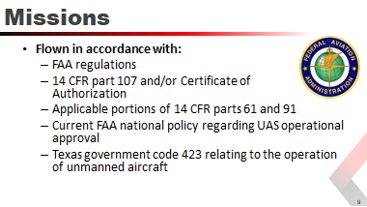
All missions will be flown in accordance with FAA regulations, 14 CFR parts 107 and/or Certificate of Authorization, applicable portions of 14 CFR parts 61 and 91, current FAA national policy regarding UAS operational approval, and Texas government code 423 relating to the operation of unmanned aircraft.
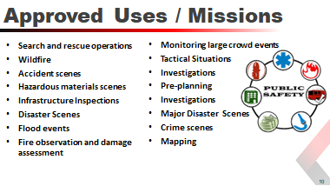
All UAS mission requests shall be authorized by the PSURT Duty Officer (or designee). Missions include, but are not limited to:
- Search and rescue operations  - Wildfire  - Accident scenes  - Hazardous materials scenes  - Infrastructure Inspections | - Disaster Scenes  - Flood events  - Fire observation and damage assessment  - Monitoring large crowd events  - Tactical Situations | - Investigations  - Pre-planning  - Investigations  - Major Disaster Scenes  - Crime scenes  - Mapping
Other case by case missions may be approved if those missions are immediately necessary. Consideration will be based on life safety, incident stabilization, and property conservation.
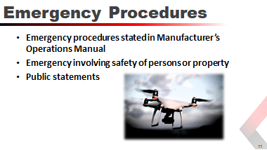
You must comply with all emergency procedures stated in the manufacturer’s operations manual for all UAS operations. In the event of an emergency involving the safety of persons or property, the RPIC may deviate from the procedures of this directive relating to aircraft, equipment, and weather minimums to the extent required for the emergency.
No member of the department, regardless of involvement in an emergency situation, shall make any statements to the general public or to news-gathering agencies without the knowledge and approval through the Public Information Office (PIO) of the effected Jurisdiction.
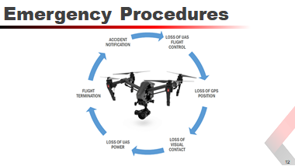
Loss of UAS Flight Controls | An interruption or loss of command and control link contact with the UAS such that the RPIC can no longer manage the aircraft’s flight and, as a result, is not operating in a predicable or planned manner.
Loss of GPS Position | Should the UAS lose GPS signal during autonomous operations, the RPIC must immediately command the UAS into manual mode and las as soon as practical.
Loss of Visual Contact | If visual contact with the UAS is lost, the RPIC shall command the aircraft into a hover and the RPIC and/or Visual Observer shall try to reestablish visual contact.
Loss of UAS Power | In case of an engine or battery failure, the UAS will not be able to maintain flight. Flight team members will immediately attempt to locate the UAS, assess the scene for injuries and render first aid if necessary.
Flight Termination | Flight termination must be executed in the event that all other contingencies have been exhausted and further flight of the UAS cannot be safely achieved or other potential hazards exist that require immediate discontinuation of flight.
Accident Notification | The RPIC must report to the FAA within 10 days of any accident that results in at least serious injury, loss of consciousness or property damage of at least $500.

Part 107, COA, and SGI
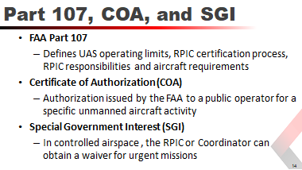

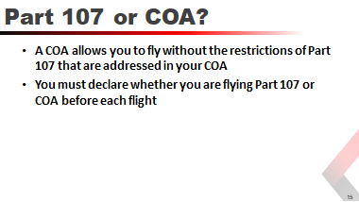

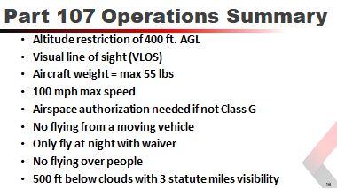
- 14 CFR Part 107 (small UAS rule) defines the operating limits, RPIC certification process, RPIC responsibilities and aircraft requirements for unmanned aircraft.
Under Part 107:
Aircraft must weigh less than 55 pounds, including everything that is onboard or otherwise attached to the aircraft, and its associated elements (including communication links and the components that control the small UA) that are required for the safe and efficient operation of the small UAS in the NAS.
Must remain within VLOS of RPIC or VO.
May not be operated over any persons not directly participating in the operation
Must yield right of way to other aircraft
Cannot go faster than 100 mph
May not go above 400 feet above ground level (AGL) or, if higher than 400 AGL, remain within 400 feet of a structure.
Cannot be operated from a moving vehicle (unless the operation is over a sparsely populated area)
Cannot be operated in a careless or reckless manner
Cannot carry hazardous material
Cannot be equipped with a weapon
For the complete list of 107 limitations, visit www.FAA.gov/UAS.
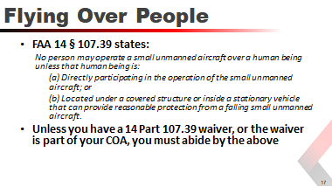

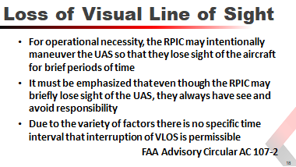

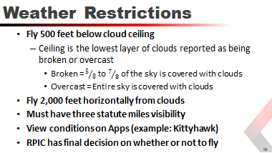

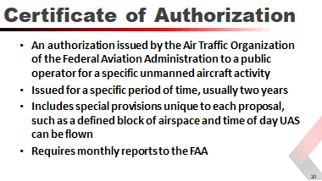
Under the statutory requirements for public aircraft (49 U.S.C. § 40102(a) and § 40125) government agencies may operate with a Certificate of Authorization to be able to self-certify UAS and operators for flights performing governmental functions.
It is important to remember that COA flights are only permitted for governmental functions. Training, maintenance and media relations flights are not considered a governmental function.
RPICs may operate UAS under the authority of Part 107 or the agencies COA but not both at the same time.
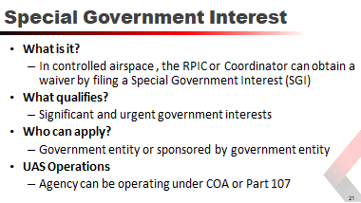
You need a Special Government Interest (SGI) if your operation falls into the “Significant and urgent government interests” category, that is, if any part of your proposed UAS operations site relates to one or more of the following:
- National defense
- Homeland security
- Law enforcement
- Emergency operations (critical infrastructure)
Requested operations must be flown by a government entity or sponsored by a government entity. The agency may be operating under an active COA or Part 107.

Understanding Airspace, NOTAM’s and TFR’s
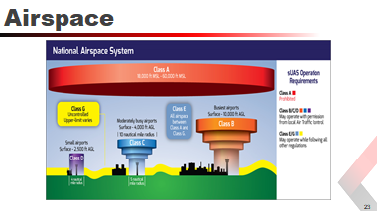
Instructor Note: Since it is primarily the RPIC’s duty to know the airspace in which they are flying, and to seek the correct authorization, use this topic as a high-level overview to briefly describe the different airspace categories.
The FAA manages the National Airspace System (NAS). The NAS is made up of a network of air navigation facilities, ATC facilities, airports, technology, and appropriate rules and regulations that are needed to operate the system. The FAA created the NAS to protect persons and property on the ground, and to establish a safe and efficient airspace environment for civil, commercial, and military aviation.
Understanding the airspace the UAS is operating in is a critical part of mission planning and airspace deconfliction. A VO must have the knowledge to help the RPIC stay within authorized airspace at all times.
The NAS is comprised of 6 different types of airspace: Class A, B, C, D, E & G.
- Class G airspace does not require authorization
- Class B, C, D and E airspace requires prior approval through LAANC (Low Altitude Authorization and Notification Capability)
Most UAS operations will be conducted in Class G airspace. UAS may be operated from the surface to 400 feet above ground level (AGL) or, if higher than 400 AGL, remain within 400 feet of a structure unless otherwise approved by waiver.
Class | Height | Description
Class A | 18,000 - 60,000 ft. MSL | UAS prohibited in this airspace
Class B | Surface - 10,000 ft. AGL | High-density airports  Designed to regulate flow  Varying altitudes  Must have permission
Class C | Surface - 4,000 ft. AGL | Moderately busy airports  5 - 10 nautical mile radius
Class D | Surface - 2,500 ft. AGL | Local air traffic control tower  Sequences traffic  No separation services  4 nautical mile radius  Must have permission
Class E | 700/1,200 ft. AGL – 18,000 | All airspace between Class A and Class G.  Fills gaps between B, C, D airspace  Sequences traffic  No separation services  Regulations allow flight
Class G | Surface - Varies | Uncontrolled airspace  Upper limit varies  Most UAS flying done here  Must follow Part 107/COA

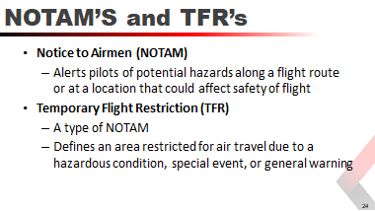
A NOTAM is written notification issued to RPIC’s providing information about the NAS.
A Temporary Flight Restriction or TFR is an area that is restricted from aircraft. This is normally due to a large sporting event or VIP movements. You need special permission from the FAA to fly in a TFR.

Night Operations
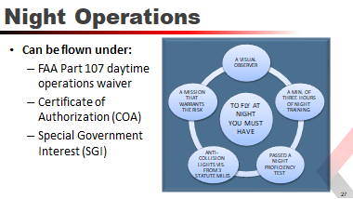
Night operations have unique challenges that require an understanding of how vision works at night as well as an increased understanding of the hazards and dangers involved.
The daytime operations waiver is for uncontrolled airspace (Class G). If you need to fly in controlled airspace, you must apply separately for airspace authorization if it is not included in your COA.
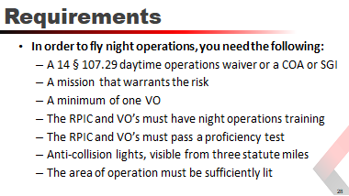

How the Eye Works
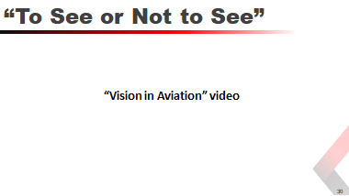
Instructor Note: This is a 15-minute video. After watching, use the next few slides to review what was covered in the video.

Limitations of Cone Cells (Our Day Camera)
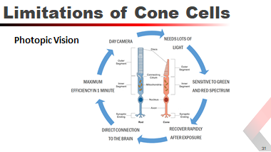
Photopic vision or cone vision is like a camera with very slow film. It can shoot pictures very quickly in the right light but produces poor out of focus pictures in dim light.
- Needs lots of light (works poorly in low light levels)
- Are most sensitive to light in the green to red spectrum
- 580 nm range (predominately adjusted to sunlight)
- Highest concentration of cells (green and red)
- Can discern some contrast below color threshold
- Recover rapidly after exposure (100 times faster than rod cells)
- Direct connection to the brain via their dedicated ganglion cells
- Can reach maximum efficiency in less than one minute

Limitations of Rod Cells (Our Night Camera)
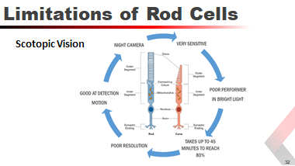
Scotopic vision or rod vision is like a camera with very fast film. Too much light will overexpose the film. It produces low resolution, poor detail images.
- Poor performer in bright conditions (overexposed picture)
- Most sensitive about 507 nm (moonlight has the same spectrum as sun light)
- Good at detecting motion
- Fires quickly (1/1000 of a sec) but recovers very slowly (1/5 sec)
- Has no direct Ganglion cell and many use the same pathway
- Takes as much as 45 minutes to reach 80% capability
- Multiple cells connect through a single connection (poor resolution)

Mesopic Vision
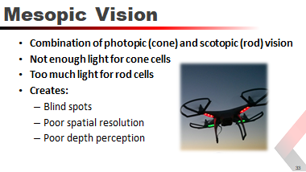

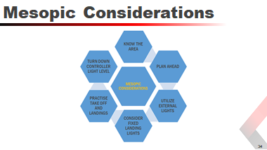
 | Know the area and plan ahead | Study the area you are going to operate in identifying a takeoff/landing point free of shadows. Define minimum altitudes prior to the mission to minimize risk
 | Utilize external lights | Have available a lighting source to illuminate your LZ. Fly from an area that is free from flashing lights, headlights or other variable light sources.
 | Consider fixed landing lights | Fixed landing lights can illuminate your LZ and in an emergency provide lighting directly below the aircraft.
 | Practice taking off and landing | Prior to the mission test your LZ to ensure you have adequate lighting to take off and land safely, if not, reposition your LZ and test again.
 | Turn down controller light level | Reducing the brightness level on your controller (Crystal Sky, iPad, etc.) will reduce the strain on your eyes and allow them to compensate for the low light levels more easily.
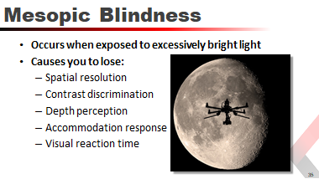
If, during low light conditions, you are exposed to excessively bright lights, your central vision will be blind and the rod cells will be bleached for several minutes.
If this occurs, put the aircraft in a safe hover and allow your vision to recover.

Spatial Disorientation and Visual Illusions
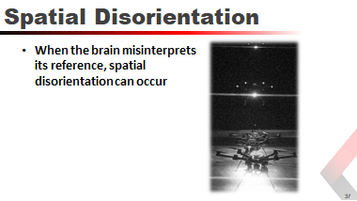
It is important to remember that the brain has to interpret the scenes based upon certain rules and criteria that have been learned over the experience of the person. When the brain misinterprets its reference, spatial disorientation can occur.
You need to recognize where these misinterpretations are most likely to occur and to be prepared for such instances.
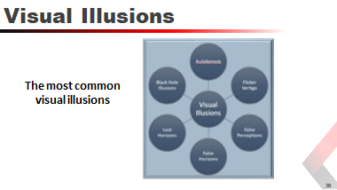
 | Autokenesis | The movement of a single light when stared at for a period of time caused by the brain attempting to isolate the light within the visual field. The eye and brain are turning on and off bipolars and ganglion cells in an attempt to establish reference and edges. Mitigate by focusing your eyes at varying distances, and increasing the speed of visual scanning.
 | Flicker Vertigo | This is more a condition than an illusion. It is caused by flicker lights at a steady rhythm and can induce nausea or dizziness. Mitigate with continual scanning.
 | False Perceptions | Lack of distant horizon. The brain references the horizon to determine it’s “up" condition. Without a visible or detectable horizon, the brain can lose it reference.
 | False Horizons | Believing a line of sight (lights along a road, lights along a coastline, or clouds) is the actual horizon when it is not. This leads to spatial disorientation.
 | Lost Horizons | Turning from a brightly lit area to a dark area causes the loss of a dark horizon. If the RPIC is in a takeoff rotation, or making a turn when the lights are extinguished, spatial disorientation could ensue.
 | Black Hole Syndrome / Black Hole Approach | Can occur at airports where there is darkness between you and the lit runway environment, with an obscured horizon (such as when the airport lighting drives the central vision and the dark horizon is lost to the peripheral retina).
Example of Autokenesis

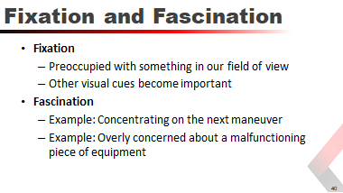
We become visually fixated in flight when our central vision becomes preoccupied with something in our field of view or when other cues which our visual system has chosen to ignore are of more importance.
We become mentally fascinated with something in flight such as concentrating hard on the next maneuver that we forget to fly. This also happens when we become overly concerned about some light activation or malfunctioning piece of equipment.
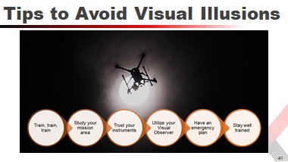

Improving Your Night Vision
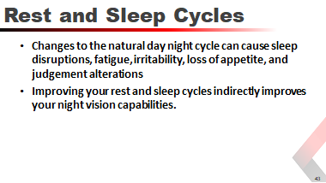
Circadian cycles in humans are triggered by special ganglion cells connected to the brain that are regulated by exposure to sun light.
These ganglion cells regulate the supra chiasmatic nucleus which is the time keeper in the brain.

The Who, What, and When of Being a VO
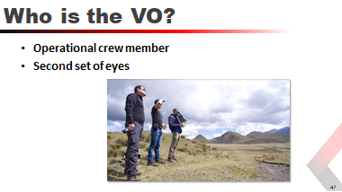
A VO is an optional crew member for a flight mission who serves as a second set of eyes, monitoring the drone in flight in order to support the RPIC.
Simply put, the VO helps the RPIC by communicating crucial information needed to ensure the safe operation of the UAS.
Although a VO is not required by the FAA for daytime drone missions having one is certainly useful, and can help lessen the RPICs workload.
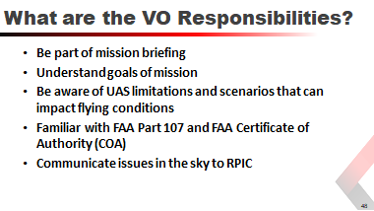
- The VO should be part of the mission briefing and understand the goals of the mission.
- The VO needs to be aware of the limitations of the UAS and how they relate to the mission.
- The VO should be aware of scenarios that can impact flying conditions, including weather conditions, environmental factors, obstacles, ground hazards and airborne hazards.
- The VO should be familiar with FAA Part 107 (small UAS rule) and FAA Certificate of Authority (COA) and how these regulations apply to the mission.
- The VO responsibility is to identify issues in the sky and direct the RPIC to take the action necessary to avoid those issues.
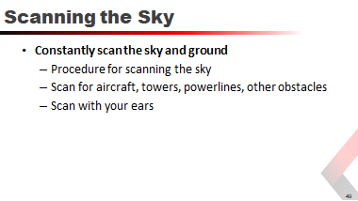
The VO should constantly scan the skies and the ground to identify potential hazards and notify the RPIC of those hazards as they arise.
- It is important for the VO to have a procedure in place for how to scan the sky. This way the VO is not simply looking all around but has a systematic approach to monitoring the airspace.
- Your primary purpose is scanning for aircraft but this technique can also be used for tower, powerlines and other obstacles.
- The VO should also scan with their ears. If you hear an aircraft begin your visual scanning technique to locate the aircraft and advise the RPIC.

Procedure for Scanning the Sky
- Begin your scan by looking at the 12 o’clock position, high in the sky.
- Scan from left to right, from the 9 o’clock to the 3 o’clock positions on the clock, making sure to cover the same points / airspace the PIC is currently flying in.
- Then, starting at the 3 o’clock position, look down and scan back to the left 9 o’clock position.
- If necessary, look farther downward and scan back to the 3 o’clock position.
- Rotate 180 degrees to scan the 3 to 9 o’clock position, covering 3 to 9 o’clock positions that are directly behind the PIC, using the same high/medium/low sky sections.
- Start over and repeat.
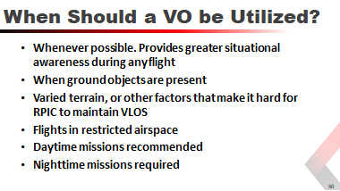

Appendix A: Form Examples

PSURT UAS Visual Observer Checklist
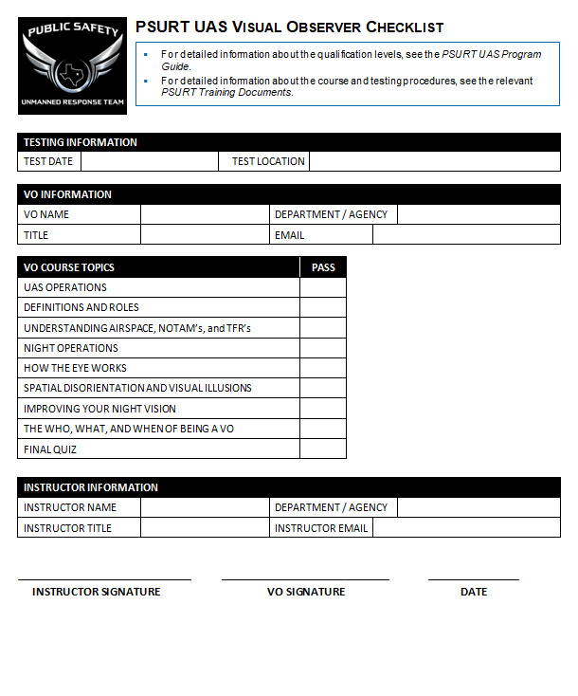

PSURT UAS Visual Observer Certification Form
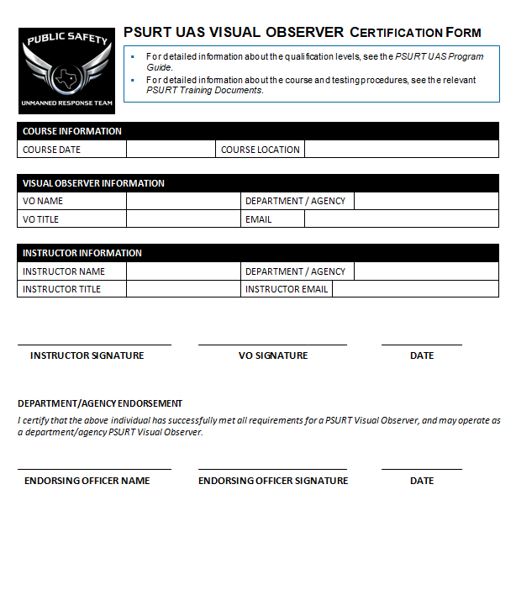

PSURT UAS RPIC/VO Night Mission Pre-Flight Quiz
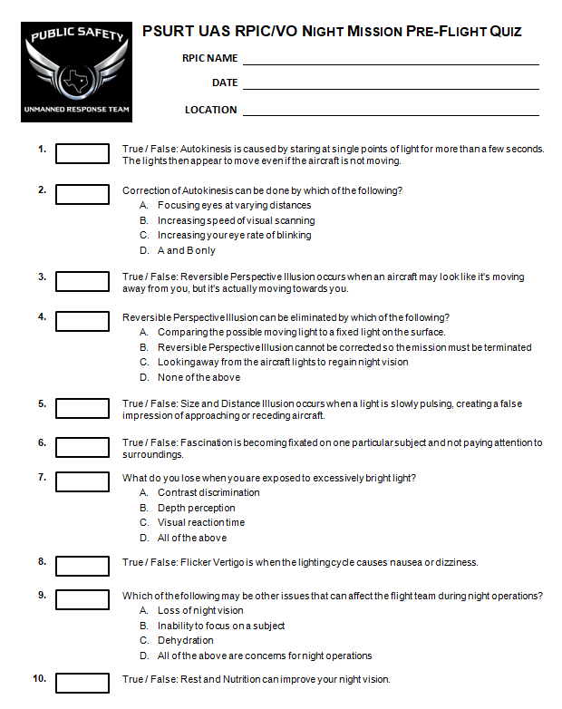

Answers: 1 (True); 2 (D), 3 (True), 4 (A), 5 (True), 6 (True), 7 (D), 8 (True), 9 (D), 10 (True)

PSURT UAS Course Evaluation Form
