PSURT UAS RPIC Level 2 Course

___________________________________
Student Guide

The vision of the participating departments and agencies is to create baselines for emerging technologies and standards for integrating them into existing emergency response, establish coordination between private and public, local and regional stakeholders to bridge the gaps in resource and capability sharing, and increase situational awareness and incident command decisions at emergency scenes.
This document establishes standard guidelines for training UAS RPIC for departmental as well as multi-agency missions.

Contents
Welcome and Overview 1
UAS Night Operations 4
How the Eye Works 6
Limitations of Cone Cells (Our Day Camera) 6
Limitations of Rod Cells (Our Night Camera) 7
Mesopic Vision 7
Spatial Disorientation and Visual Illusions 9
Improving Your Night Vision 11
Thermographics 12
Camera and Software Demonstration 14
Pre-Flight Quiz 15
Hands-On Test: Basic Proficiency 16
Hands-On Training: Scenario-Based 17
Scenario 1a: Search and Identify (Law Enforcement) 18
Scenario 1b: Search and Identify (Emergency Response) 19
Scenario 2a: Track Suspect (Law Enforcement) 20
Scenario 2b: Locate Alzheimer’s Patient (Emergency Response) 21
Scenario 3: Search and Rescue 22
RPIC Qualification Check 23
Skills Evaluated 23
Position (Maneuvering 1) 24
Position (Maneuvering 2) 25
Curriculum Objectives 26

Welcome and Overview
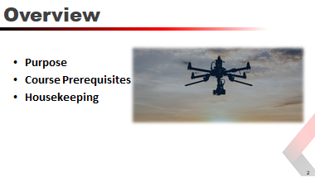
Purpose
The purpose of the PSURT UAS RPIC Level 2 course is to provide emergency response personnel who have received their FAA Part 107 Remote Pilot certificate, and completed the PSURT UAS Level 1 Course, the training necessary to safely operate UAS at night.
Course Prerequisites
- The student must have their FAA Part 107 Remote Pilot certificate prior to attending the course.
- The student must have completed the PSURT UAS RPIC Level 1 Course.
- It is recommended that the student have at least five hours of logged day flights prior to attending this course.
Housekeeping
Cover any needed housekeeping topics, such as breaks and directions to the restroom.
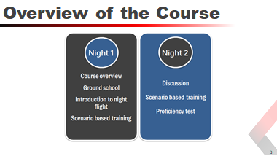
Course Structure
This two-day program is divided into three main sections:
- Ground School
- Practical Training
- Proficiency Course
Ground School — The two-hour classroom ground school covers the following topics:
- Night Operations
- How the Eye Works
- Spatial Disorientation and Visual Illusions
- Improving Your Night Vision
- Thermographics
Practical Training — The hands on training course will provide the students with the practical experience to safely operate the UAS at night in the field. During the two days, students will learn how to operate the UAS safely in low light conditions and practice tactical scenarios.
Proficiency Course — Based on the National Institute of Standards and Technology (NIST) Remote Pilot Proficiencies Using Standard Test Methods, students are required to successfully pass a proficiency course. The course measures each student’s ability to operate the UAS safely while demonstrating their ability to operate the UAS and the onboard camera in a variety of situations.
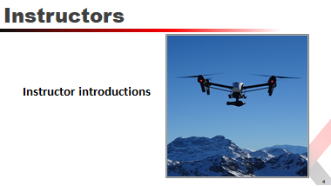

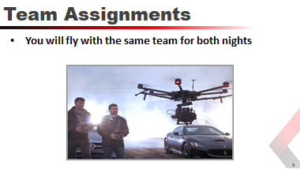

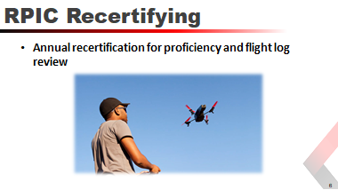
Each certification is valid for one year from the date of the test, at which time the RPIC must recertify on each aircraft they fly. The recertification is a one-day class that includes ground school and a hands-on flight test.
- Ground school covers rules and regulations that have changed in the past year, as well as new and revised best practices learnt in the field. In addition, the RPIC is required to pass a written test similar to the recurrent Part 107 test that includes questions about airspace, maps, weather, mission planning, FAA rules and regulations, among other topics. Both Level 1 and Level 2 RPIC’s complete the test; however, there is an additional section in the test for Level 2 RPIC’s to complete that covers night operations.
- The hands-on flight test is scenario-based using one or more of the scenarios in the Level 1 or Level 2 training courses.

UAS Night Operations
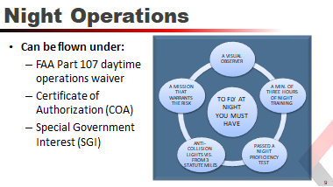
Night operations have unique challenges that require an understanding of how vision works at night as well as an increased understanding of the hazards and dangers involved.
The daytime operations waiver is for uncontrolled airspace (Class G). If you need to fly in controlled airspace, you must apply separately for airspace authorization if it is not included in your COA.
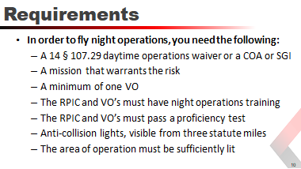
Night operations training and review should include:
- FAA Pilot’s Handbook of Aeronautical Knowledge, Chapter 17: Aeromedical Factors (pages 17-22 through 17-29) https://www.faa.gov/regulations_policies/handbooks_manuals/aviation/phak/
- FAA Helicopter Flying Handbook, Chapter 13: Night Operations https://www.faa.gov/regulations_policies/handbooks_manuals/aviation/helicopter_flying_handbook/
- Review FAA video, “FAA TV: Vision in Aviation” (https://www.faa.gov/tv/?mediaId=467)
- Proficiency Test just prior to the mission

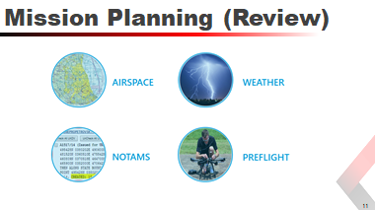

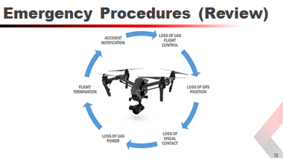

How the Eye Works
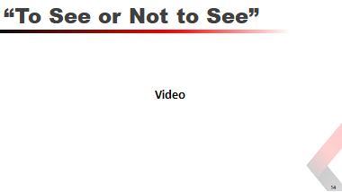

Limitations of Cone Cells (Our Day Camera)
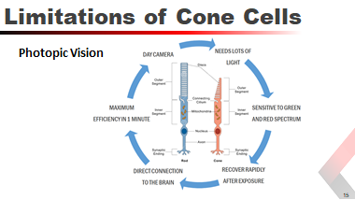
Photopic vision or cone vision is like a camera with very slow film. It can shoot pictures very quickly in the right light but produces poor out of focus pictures in dim light.
- Needs lots of light (works poorly in low light levels)
- Are most sensitive to light in the green to red spectrum
- 580 nm range (predominately adjusted to sunlight)
- Highest concentration of cells (green and red)
- Can discern some contrast below color threshold
- Recover rapidly after exposure (100 times faster than rod cells)
- Direct connection to the brain via their dedicated ganglion cells
- Can reach maximum efficiency in less than one minute

Limitations of Rod Cells (Our Night Camera)
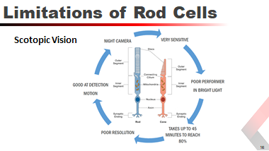
Scotopic vision or rod vision is like a camera with very fast film. Too much light will overexpose the film. It produces low resolution, poor detail images.
- Poor performer in bright conditions (overexposed picture)
- Most sensitive about 507 nm (moonlight has the same spectrum as sun light)
- Good at detecting motion
- Fires quickly (1/1000 of a sec) but recovers very slowly (1/5 sec)
- Has no direct Ganglion cell and many use the same pathway
- Takes as much as 45 minutes to reach 80% capability
- Multiple cells connect through a single connection (poor resolution)

Mesopic Vision
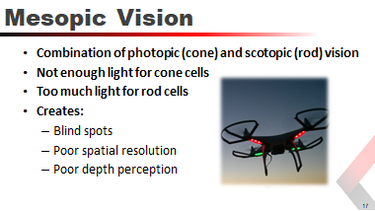

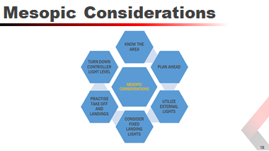
 | Know the area and plan ahead | Study the area you are going to operate in identifying a takeoff/landing point free of shadows. Define minimum altitudes prior to the mission to minimize risk
 | Utilize external lights | Have available a lighting source to illuminate your LZ. Fly from an area that is free from flashing lights, headlights or other variable light sources.
 | Consider fixed landing lights | Fixed landing lights can illuminate your LZ and in an emergency provide lighting directly below the aircraft.
 | Practice taking off and landing | Prior to the mission test your LZ to ensure you have adequate lighting to take off and land safely, if not, reposition your LZ and test again.
 | Turn down controller light level | Reducing the brightness level on your controller (Crystal Sky, iPad, and so on) will reduce the strain on your eyes and allow them to compensate for the low light levels more easily.
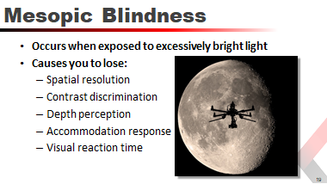
If, during low light conditions, you are exposed to excessively bright lights, your central vision will be blind and the rod cells will be bleached for several minutes.
If this occurs, put the aircraft in a safe hover and allow your vision to recover.

Spatial Disorientation and Visual Illusions
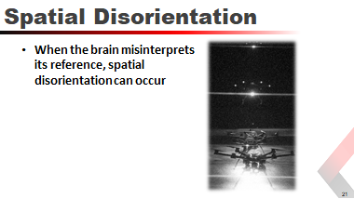
It is important to remember that the brain has to interpret the scenes based upon certain rules and criteria that have been learned over the experience of the person. When the brain misinterprets its reference, spatial disorientation can occur.
You need to recognize where these misinterpretations are most likely to occur and to be prepared for such instances.
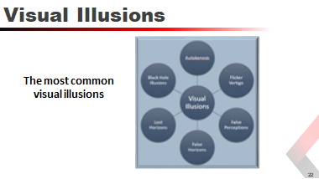
 | Autokenesis | The movement of a single light when stared at for a period of time caused by the brain attempting to isolate the light within the visual field. The eye and brain are turning on and off bipolars and ganglion cells in an attempt to establish reference and edges. Mitigate by focusing your eyes at varying distances, and increasing the speed of visual scanning.
 | Flicker Vertigo | This is more a condition than an illusion. It is caused by flicker lights at a steady rhythm and can induce nausea or dizziness. Mitigate with continual scanning.
 | False Perceptions | Lack of distant horizon. The brain references the horizon to determine it’s “up" condition. Without a visible or detectable horizon, the brain can lose it reference.
 | False Horizons | Believing a line of sight (lights along a road, lights along a coastline, or clouds) is the actual horizon when it is not. This leads to spatial disorientation.
 | Lost Horizons | Turning from a brightly lit area to a dark area causes the loss of a dark horizon. If the RPIC is in a takeoff rotation, or making a turn when the lights are extinguished, spatial disorientation could ensue.
 | Black Hole Syndrome / Black Hole Approach | Can occur at airports where there is darkness between you and the lit runway environment, with an obscured horizon (such as when the airport lighting drives the central vision and the dark horizon is lost to the peripheral retina).
Example of Autokenesis

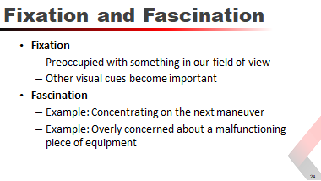
We become visually fixated in flight when our central vision becomes preoccupied with something in our field of view or when other cues which our visual system has chosen to ignore are of more importance.
We become so mentally fascinated with something in flight, such as concentrating hard on the next maneuver, that we forget to fly. This also happens when we become overly concerned about some light activation or malfunctioning piece of equipment.
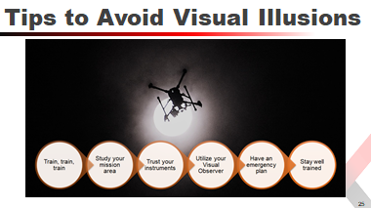

Improving Your Night Vision
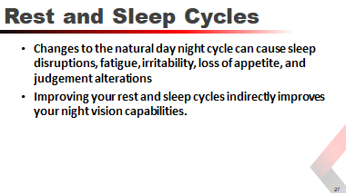
Circadian cycles in humans are triggered by special ganglion cells connected to the brain that are regulated by exposure to sunlight.
These ganglion cells regulate the supra chiasmatic nucleus which is the time keeper in the brain.
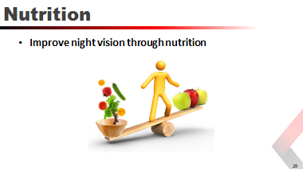

Thermographics
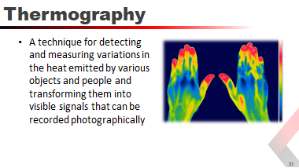

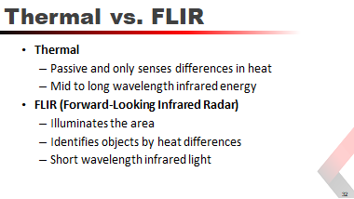
FLIR is slightly different from thermal imaging in that thermal imaging cameras are passive and only sense differences in heat. FLIR systems use the infrared light to illuminate an area as well as identify objects by heat differences. This type of system is useful in search and rescue missions, large fires (especially in defensive modes), wildland fires, hazardous materials and just about any other scene where an elevated thermal image would be helpful.
- Spot metering and area measurement
- Isotherm mode
- Temperature alert
- Photo / video mode
- Region of Interest (ROI)
- Palette
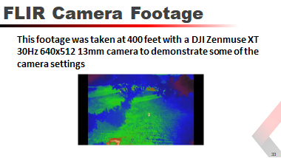

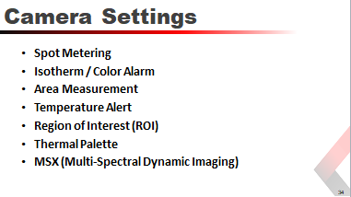
Different cameras include different features. These are some common settings:
Spot Metering | Measure temperature, within a few degrees, of a small area
Isotherm / Color Alarm | Designate temperature ranges represented by different colors. Highlight a specific temperature level; grays out all other temperatures
Area Measurement | Display average, low, and high temperatures
Temperature Alert | Display on-screen notification when highest temperature exceeds your specified value
Region of Interest (ROI) | Maximize contrast for regions of highest interest. Example, exclude sky
Thermal Palette | Different color choices to improve contrast, depending on the type of image you are viewing
MSX (Multi-Spectral Dynamic Imaging) | Adds visible light details for greater clarity

Camera and Software Demonstration
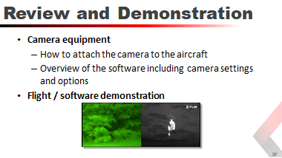
Instruction and demonstration on the camera controls and settings, including:
- Spot metering and area measurement
- Isotherm mode
- Temperature alert
- Photo / video mode
- Region of Interest (ROI)
- Palette

Pre-Flight Quiz
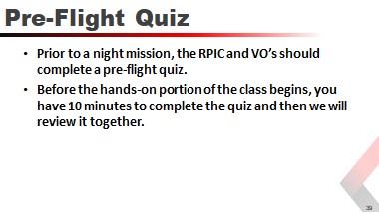

Hands-On Test: Basic Proficiency
Prior to beginning scenario-based training, students will demonstrate their ability to safely and proficiently operate the UAS at night by completing the following without assistance:
- Set up the mission area and landing zone to ensure:
A designated cordoned space for sage takeoffs and landings
Proper and adequate lighting for takeoffs and landings
- Perform a preflight inspection
- Power on the controller
- Power on the aircraft
- Connect the flight display and start the flight software
- Set up and turn on the strobe lights required for night operations
Students will conduct a series of flights at a variety of altitudes per the instructor’s directions.
Students will demonstrate the ability to adjust the thermal / FLIR camera controls and settings, including taking stills and video, and SD card management.

Hands-On Training: Scenario-Based
This section includes three scenarios:
- Scenario 1: Search and Identify
Scenario 1a: Suspect (Law Enforcement)
Scenario 1b: HAZMAT Event (Emergency Response)
- Scenario 2a: Track Suspect (Law Enforcement)
- Scenario 2b: Locate Alzheimer’s Patient (Emergency Response)
- Scenario 3: Search and Rescue

Scenario 1a: Search and Identify (Law Enforcement)

 | Suspect
Props: |  | Vehicle, License Plates, Gun, Hat, Evidence
Flight Time: |  | Each RPIC should get one hour of flight time during the scenario.
Scenario: |  | It is believed that a homicide suspect is hiding in his truck surrounded by brush. A helicopter crew was dispatched to locate the vehicle. The crew located the vehicle but due to limitations of thermal cameras was unable to see inside the windows. Shortly after they located the vehicle, the weather conditions required that the helicopter return to base. UAS team is called to attempt to determine if the suspect is still in the vehicle and assist ground units in approaching the vehicle.
Student Actions: |  | RPIC #1 operates an aircraft with a thermal camera. RPIC #2 operates an aircraft with a spot light in order to ascertain the location of the suspect.  - Two RPIC’s launch from the designated coordinates and locate the vehicle based on the GPS coordinates relayed by the helicopter crew.  - After RPIC #1 has located the vehicle with the thermal camera, RPIC #2 utilizes RPIC #1’s display to safely lower the aircraft into position, providing a view inside the driver’s side window.  - After confirmation of the suspect location is achieved, RPIC #2 flies around the vehicle and provides a description of the vehicle and any additional occupants.  - RPIC #1 continues to provide overwatch of the scene.  - After it is determined that there is no threat from the suspect, RPIC #1 guides ground units in to arrest the suspect.  Non-flying students fill the role of visual observers. VO’s simulate utilizing the UAS radio channel to relay pertinent information back to command. If the flight crew is enabled using DroneSense, VO’s shall demonstrate the ability to access the Ops Center for viewing of video streaming and to assist with airspace deconfliction.
Expectations: |  | Students are expected to demonstrate the ability to effectively communicate and coordinate activities.  Students must identify the primary (#1) RPIC and the secondary (#2) RPIC.  Students must demonstrate the ability to properly maintain a safe altitude from each other.  Utilizing the onboard thermal camera, students must demonstrate the ability to perform a search for a vehicle.  Utilizing the camera and spotlight, students must demonstrate the ability to lower the aircraft into position around the vehicle to gain situational awareness.
After Action: |  | After all criteria have been met, both RPIC’s safely land their aircraft and discuss the scenario with the instructor. Each student is required to be the primary and secondary RPIC in this scenario.

Scenario 1b: Search and Identify (Emergency Response)

 | HAZMAT Event
Props: |  | Pickup truck, 55 gallon drums or hazardous material tote(s), HAZMAT placards, liquid to simulate spill.
Flight Time: |  | Each RPIC should get one hour of flight time during the scenario.
Scenario: |  | It is believed that a vehicle transporting hazardous material has been abandoned in an area surrounded by brush. A helicopter crew was initially dispatched to locate the vehicle. The crew located the vehicle; however, due to limitations of thermal cameras, they were unable to visualize the contents of the material being carried in the bed of the vehicle. Shortly after they located the vehicle, the weather conditions required that the helicopter return to base. A UAS team is called to attempt to determine if the driver is still in the vehicle and assist ground units in approaching the vehicle and determining the contents of the pickup bed.
Student Actions: |  | RPIC #1 operates an aircraft with a thermal camera. RPIC #2 operates an aircraft with a spotlight in order to ascertain the location of the suspect.  - Two RPIC’s launch from the designated coordinates and locate the vehicle based on the GPS coordinates relayed by the helicopter crew.  - After RPIC #1 has located the vehicle with the thermal camera, RPIC #2 utilizes RPIC #1’s display to safely lower the aircraft into position, providing a view inside the driver’s side window.  - After confirmation of the driver is achieved, RPIC #2 orbits around the vehicle and provides a description of the vehicle and the contents of the pickup bed.  - RPIC #1 continues to provide overwatch of the scene.  - After it is determined that there is no clear threat from the contents of the storage vessels, RPIC #1 guides ground units into the area for further response.  Non-flying students fill the role of visual observers. VO’s simulate utilizing the UAS radio channel to relay pertinent information back to command. If the flight crew is enabled with DroneSense, VO’s shall demonstrate the ability to access the Ops Center for viewing of video streaming and to assist with airspace deconfliction.
Expectations: |  | Students are expected to demonstrate the ability to effectively communicate and coordinate activities.  Students must identify the primary (#1) RPIC and the secondary (#2) RPIC.  Students must demonstrate the ability to properly maintain a safe altitude from each other.  Utilizing the onboard thermal camera, students must demonstrate the ability to perform a search for a vehicle.  Utilizing the camera and spot light, students must demonstrate the ability to lower the aircraft into position around the vehicle to gain situational awareness.
After Action: |  | After all criteria have been met, both RPIC’s safely land their aircraft and discuss the scenario with the instructor. Each student is required to be the primary and secondary RPIC in this scenario.

Scenario 2a: Track Suspect (Law Enforcement)

Props: | Instructor to act as suspect.
Flight Time: | Each RPIC should get one hour of flight time during the scenario.
Scenario: | Armed suspects are loose in a suburban neighborhood. The perimeter is set by ground units. Due to weather minimums and length of flight, the helicopter crew is unable to assist. A UAS team is deployed to conduct an aerial search utilizing the thermal camera.
Student Actions: | - Two RPIC’s launch from the designated location and conduct a coordinated search of the area based on information received from ground units.  Non-flying students fill the role of visual observers. VO’s simulate utilizing the UAS radio channel to relay pertinent information back to command. If the flight crew is enabled using DroneSense, VO’s shall demonstrate the ability to access the Ops Center for viewing of video streaming and to assist with airspace deconfliction.
Expectations: | Students are expected to demonstrate the ability to effectively communicate and coordinate activities.  Students must identify the primary (#1) RPIC and the secondary (#2) RPIC.  Students must demonstrate the ability to properly maintain a safe altitude from each other.  Utilizing the onboard thermal cameras, students must demonstrate the ability to perform an aerial search of the neighborhood and locate the suspect. Once located the students must demonstrate the ability to “walk in” ground units safely.
After Action: | After all criteria have been met, both RPIC’s will safely land their aircraft and discuss the scenario with the instructor. Each student will be required to be the primary and secondary RPIC in this scenario.

Scenario 2b: Locate Alzheimer’s Patient (Emergency Response)

Props: | Instructor to act as patient.
Flight Time: | Each RPIC should get one hour of flight time during the scenario.
Scenario: | An Alzheimer’s patient has left a care facility in a suburban neighborhood. The perimeter is being searched by ground units. Due to weather minimums and length of flight, the helicopter crew is unable to assist. A UAS team is deployed to conduct an aerial search utilizing the thermal camera.
Student Actions: | - Two RPIC’s launch from the designated location and conduct a coordinated search of the area based on information received from ground units.  Non-flying students fill the role of visual observers. VO’s simulate utilizing the UAS radio channel to relay pertinent information back to command. If the flight crew is enabled using DroneSense, VO’s shall demonstrate the ability to access the Ops Center for viewing of video streaming and to assist with airspace deconfliction.
Expectations: | Students are expected to demonstrate the ability to effectively communicate and coordinate activities.  Students must identify the primary (#1) RPIC and the secondary (#2) RPIC.  Students must demonstrate the ability to properly maintain a safe altitude from each other.  Utilizing the onboard thermal cameras, students must demonstrate the ability to perform an aerial search of the neighborhood and locate the Alzheimer’s patient. After the patient has been located, the students must demonstrate the ability to “walk in” ground units safely.
After Action: | After all criteria have been met, both RPIC’s will safely land their aircraft and discuss the scenario with the instructor. Each student will be required to be the primary and secondary RPIC in this scenario.

Scenario 3: Search and Rescue

Props: | Child Size Analog, hand warmers / heat packs
Flight Time: | Each RPIC should get one hour of flight time during the scenario.
Scenario: | Provide the last know location of a child lost in the woods, two teams plan a search pattern, find, and identify location.
Student Actions: | - Prior to the start of the mission the students conduct a mission brief to decide the best course of action to accomplish the objective. Utilizing the map on the screen the RPIC’s will coordinate a search area.  - After a plan is in place, two RPIC’s launch and begin searching the area. If the lost child is located, the GPS coordinates of the child are relayed to the instructor.  Non-flying students fill the role of visual observers. VO’s simulate utilizing the UAS radio channel to relay pertinent information back to command. If the flight crew is enabled using DroneSense, VO’s shall demonstrate the ability to access the Ops Center for viewing of video streaming and to assist with airspace deconfliction.
Expectations: | Students are expected to demonstrate the ability to effectively communicate and coordinate activities.  Students must demonstrate the ability to use the map and plan a search pattern.  Utilizing the onboard thermal camera and map functions, students must demonstrate the ability to perform an aerial search in a wooded area.  Students must demonstrate the ability to fly at tree top altitudes and locate a missing child.  Students must demonstrate the ability to relay GPS coordinates of the UAS.
After Action: | After all criteria have been met, both RPIC’s will safely land their aircraft and discuss the scenario with the instructor. Each student will be required to be the primary and secondary RPIC in this scenario.

RPIC Qualification Check
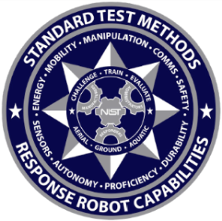
This UAS proficiency course ensures that all department Remote Pilots in Command (RPIC) have the skills necessary to safely operate a UAS at night.
This proficiency course is based on the National Institute of Standards and Technology (NIST) Guide to Measuring and Comparing UAS Capabilities and Remote Pilot Proficiencies Using Standard Test Methods.
The course is untimed and RPIC’s can retest on any areas they do not successfully complete the first time.
Inside each bucket is an inscribed ring to evaluate alignment. Center targets can be letters, visual/color/thermal, acuity charts, hazmat labels, or other items.

For proficiency testing objectives based on the NFPA standards for public safety UAS, see Curriculum Objectives.

Skills Evaluated
Hold Position and Altitude | Establish and hold a hover position and orientation
Orbit a Point | Move position and rotate around a point
Fly Straight and Level | Fly straight and level for short distances
Identify and Inspect Objects | Move and rotate around an object of interest to identify key features and inspect key details from close proximity
Land Accuracy | Land accurately from vertical and downward 90-degree descending approaches
In order to count an observation successful, a RPIC must view the entire ring inside each bucket. If any portion of the ring is obscured, they should maneuver their aircraft until the entire ring is in view before moving on to the next bucket.
X
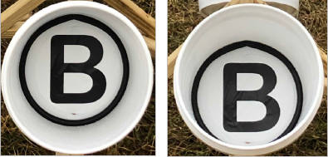

Position (Maneuvering 1)
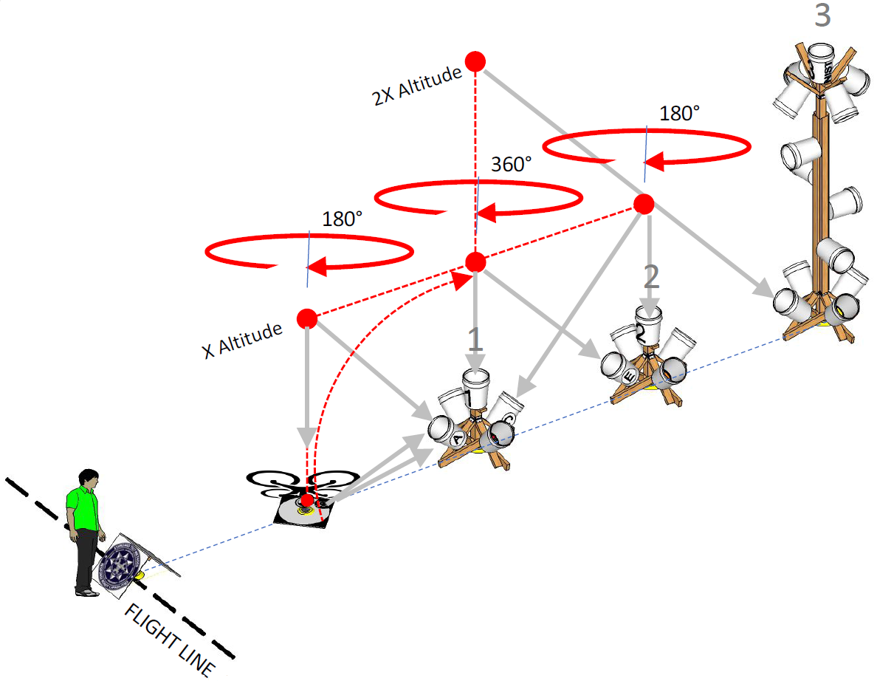

Task # | Maneuver | Locate
1 | Launch to 10ft and hover over Stand #1 | 1 & 2E
2 | Rotate right 360° over Stand #1 | 1 & 2E
3 | Rotate left 360° over Stand #1 | 1 & 2E
4 | Climb to 20ft over Stand #1 | 1 & 2E
5 | Descend to 10ft over Stand #1 | 1 & 2E
6 | Forward over Stand #2 | 2 & 3I
7 | Backward over Stand #1 | 1 & 2E
8 | Forward over Stand #2 and rotate right 180° | 2 & 1C
9 | Forward over Landing Platform and rotate left 180° | L & 1A
10 | Land centered facing stands

Position (Maneuvering 2)
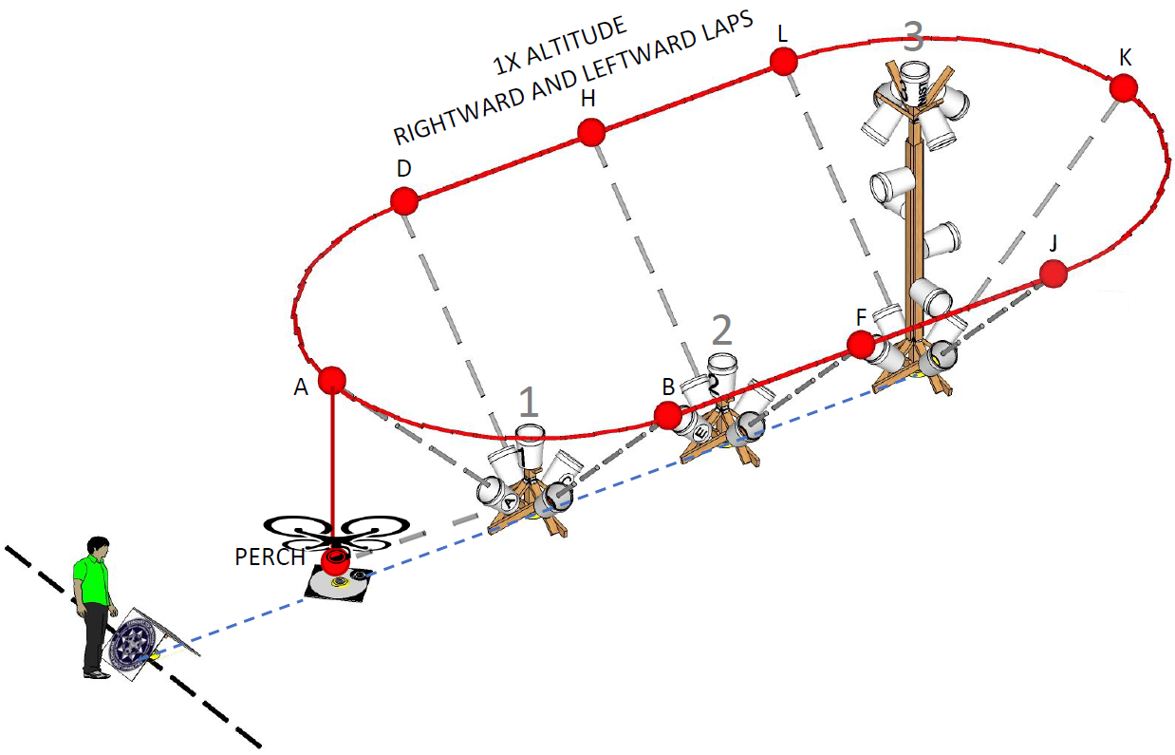
Task # | Maneuver | Locate
11 | Launch to 10ft and hover over Landing Platform | 1A
12 | Traverse right around the training apparatus, pausing directly over each location | 1B
13 | Continue | 2F
14 | Continue | 3J
15 | Continue | 3K
16 | Continue | 3L
17 | Continue | 2H
18 | Continue | 1D
19 | Continue | 1A
20 | Land centered facing stands
21 | Launch to 10ft and hover over Landing Platform | 1A
22 | Traverse left around the training apparatus, pausing directly over each location | 1D
23 | Continue | 2H
24 | Continue | 3L
25 | Continue | 3K
26 | Continue | 3J
27 | Continue | 2F
28 | Continue | 1B
29 | Continue | 1A
30 | Land centered facing stands

Curriculum Objectives
The National Fire Protection Association has developed standards for public safety UAS that include aerial test methods developed by NIST that measure the capabilities of the drone as well as the proficiency of the RPIC. These curriculum objectives are based on the NFPA standards.
NIGHT SCHOOL OBJECTIVES
1. | The RPIC shall be able to describe different visual illusions associated with night operations.
2. | The RPIC shall be able to describe the requirements to fly a night mission.
3. | The RPIC shall demonstrate the setting up of a proper mission area for night operations.
4. | The RPIC shall demonstrate the operation of a thermal camera.
5. | The RPIC shall be able to describe the theories associated with thermographics.
6. | The RPIC shall demonstrate an understanding of thermal palettes.
7. | The RPIC shall demonstrate an understanding of spot metering and area metering.
8. | The RPIC shall demonstrate an understanding of MSX and ISO’s.
9. | The RPIC shall demonstrate a working knowledge of associated thermal camera apps and their settings and options.
10. | The RPIC shall demonstrate the ability to use mounted lighting equipment on the aircraft for navigation and assistance in identification of mission targets.

