PSURT UAS RPIC Level 1 Course

___________________________________
Student Guide

The vision of the participating departments and agencies is to create baselines for emerging technologies and standards for integrating them into existing emergency response, establish coordination between private and public, local and regional stakeholders to bridge the gaps in resource and capability sharing, and increase situational awareness and incident command decisions at emergency scenes.
This document establishes standard guidelines for training UAS RPIC’s for departmental as well as multi-agency missions.

Contents
Welcome and Overview 1
Basic Flight Principles 5
Standard Operating Procedures (SOP) for UAS Operations 7
Mission Planning 16
Night Operations 25
FAA Law Enforcement Assistance Program (LEAP) 26
Texas Government Codes 27
Case Law 32
Hands-On Training: Basic Flight 36
Setup 36
Flight Hand Signals 36
Basic Flight Maneuvers 36
Using the Camera and Setting Flight Modes 36
Flight Time 36
Test: Basic Flight Proficiency 37
Hands-On Training: Scenario-Based 38
Scenario 1a: Search and Identify (Law Enforcement) 39
Scenario 1b: Search and Identify (Emergency Response) 40
Scenario 2a: Persistent Situational Awareness (Law Enforcement) 41
Scenario 2b: Persistent Situational Awareness (Emergency Response) 42
Scenario 3: Mapping / Photogrammetry 43
Scenario 4: Overwatch / Indoor 44
Scenario 5: Search and Rescue 45
RPIC Qualification Check 46
Documentation 46
Skills Evaluated 46
Course Setup 46
Position (Maneuvering 1) 47
Position (Maneuvering 2) 48
Curriculum Objectives 49
Appendix A: Form Examples 51
PSURT UAS RPIC Level 1 Checklist 51
PSURT UAS RPIC Certification Form 52
PSURT UAS Course Evaluation Form 53
Appendix B: Building the UAS Proficiency Course 54
Appendix C: Flight Hand Signals 56

Welcome and Overview
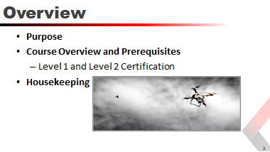
Purpose
The purpose of the PSURT UAS RPIC Course is to provide public safety personnel who have already received their FAA Part 107 Remote Pilot certificate, the necessary training to safely operate UAS for their agency or department.
Course Overview and Prerequisites
The RPIC must obtain their FAA Part 107 Remote Pilot certificate prior to attending the course.
PSURT UAS RPIC Level 1
RPIC’s who qualify for PSURT UAS RPIC Level 1 have successfully completed all of the requirements listed below and have been certified by a qualified PSURT instructor on a specific aircraft for day missions only.
- RPIC has a current FAA Part 107 Remote Pilot certificate
- RPIC has completed the following PSURT UAS RPIC Level 1 Course ground school topics:
Standard Operating Procedures
Mission Planning
Texas Government Codes
Case Law
- RPIC has completed the following PSURT UAS RPIC Level 1 Course hands-on training:
Setup
Basic flight maneuvers
Using the camera (not thermal or FLIR)
Setting flight modes
- RPIC has completed the following PSURT UAS RPIC Level 1 Course scenario-based flights:
Scenario 1: Search and Identify
Scenario 2: Persistent Situational Awareness
Scenario 3: Mapping / Photogrammetry
Scenario 4: Overwatch / Indoor
Scenario 5: Search and Rescue
- RPIC has completed the following PSURT UAS RPIC Level 1 Course proficiency tests based on the National Institute of Standards and Technology (NIST) Guide to Measuring and Comparing sUAS Capabilities and Remote Pilot Proficiencies Using Standard Test Methods:
Hold position and altitude
Orbit a point
Fly straight and level
Identify and inspect objects
Land accurately
PSURT UAS RPIC Level 2
RPIC’s who qualify for PSURT UAS RPIC Level 2 have successfully completed all of the requirements listed below and have been certified by a qualified PSURT instructor on a specific aircraft for both day and night missions.
- RPIC has a current FAA Part 107 Remote Pilot certificate
- RPIC has completed all PSURT UAS RPIC Level 1 Course requirements
- RPIC has completed the following PSURT UAS RPIC Level 2 Course ground school topics:
UAS Night Operations
How the Eye Works
Spatial Disorientation and Visual Illusions
Improving Your Night Vision
Thermographics
- RPIC has completed the following PSURT UAS RPIC Level 2 Course hands-on training:
Setup
Basic flight maneuvers
Using the camera (thermal / FLIR)
Setting flight modes
- RPIC has completed the following PSURT UAS RPIC Level 2 Course scenario-based flights:
Scenario 1: Search and Identify
Scenario 2: Search and Rescue
Scenario 3: Track Suspect
- RPIC has completed the following PSURT UAS RPIC Level 2 Course proficiency tests based on the National Institute of Standards and Technology (NIST) Guide to Measuring and Comparing sUAS Capabilities and Remote Pilot Proficiencies Using Standard Test Methods:
Hold position and altitude
Orbit a point
Fly straight and level
Identify and inspect objects
Land accurately
Housekeeping
Cover any needed housekeeping topics, such as breaks and directions to the restroom.
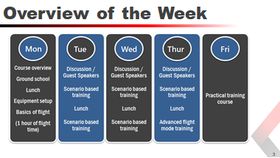
Course Structure
The program is divided into three main sections:
- Ground School
- Practical Training
- Proficiency Course
Ground School — The four-hour classroom ground school covers the following topics:
- Standard Operating Procedures  - FAA COA  - FAA Part 107 | - TX Gov Code 423 and 2205  - Case study  - National Airspace Overview | - Preflight  - Weather  - Night Flying
Practical Training — The hands-on portion of the course gives students the practical experience to safely operate the UAS in the field. Throughout the four days, students will learn the basics of UAS flight maneuvers and practice tactical scenarios.
Proficiency Course — Based on the National Institute of Standards and Technology (NIST) Remote Pilot Proficiencies Using Standard Test Methods, students are required to successfully pass a proficiency course. The course measures each student’s ability to operate the UAS safely while demonstrating their ability to operate the UAS and the onboard camera in a variety of situations.
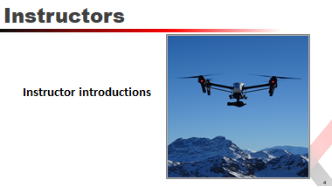

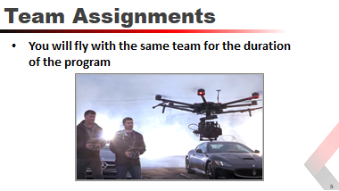

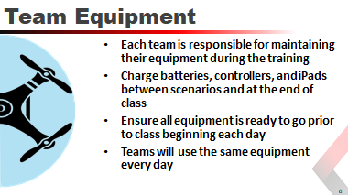

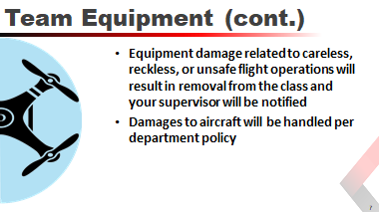

Basic Flight Principles
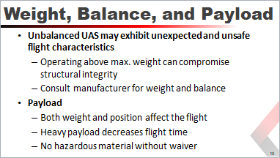

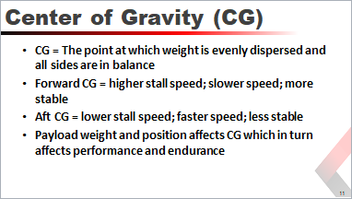

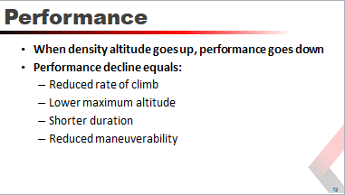
Factors that may cause you to have to reduce weight for takeoff:
- High density altitude - UAS may “feel” like it’s flying at a higher altitude.
Reduces lift
Decreases engine power output
Impairs propeller efficiency
- High elevations
- High air temperatures
- High humidity
- Surface wind
When you are at a high elevation and it is hot and humid, your aircraft performance will decrease.
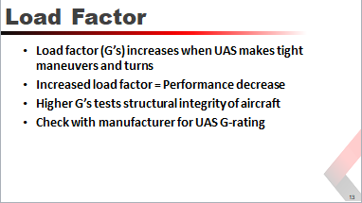

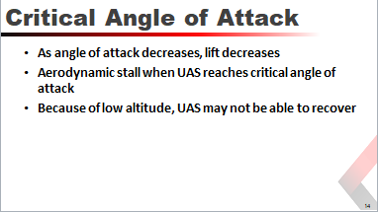

Standard Operating Procedures (SOP) for UAS Operations
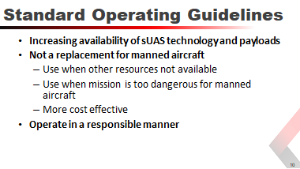
The increasing availability of low-cost small unmanned aircraft systems (UAS) technology allied with image processing applications, real-time video and various sensor payloads, offer an opportunity to collect forensic-quality scene information, provide infrastructure inspections and damage assessments, speed up incident clearance, assist in search and rescue, improve fire observation, and reduce the exposure of law enforcement officers, emergency responders and the public to hazardous conditions.
UAS are not a replacement for manned aircraft, however, they are an excellent tool to be used when those resources are unavailable, if the mission is too dangerous for manned aircraft, or when deemed more cost effective than conventional air assets.
UAS assets shall be operated in a responsible manner consistent with Department policy, Texas State laws, and federal rules and regulations; ensuring that the privacy rights of the people in the State of Texas are respected.
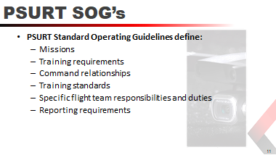
The PSURT Standard Operating Guidelines (SOG’s) define the missions, training requirements, command relationships, training standards, specific flight team responsibilities and duties, and the reporting requirements to which Department employees will adhere in order to operate and safely deploy UAS assets.
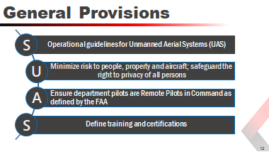
These SOG’s provide operational guidelines for Unmanned Aerial Systems (UAS). They are designed to minimize risk to people, property, and aircraft during the operation while continuing to safeguard the right to privacy of all persons.
The SOG’s were created to ensure that department employees who operate and deploy UAS assets are RPIC’s as defined by the FAA.
The SOG’s define the training and certifications necessary to operate and deploy UAS assets and establishes guidelines and best practices for RPIC’s to follow.
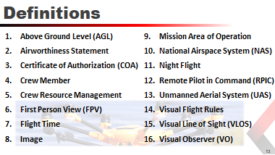
Above Ground Level (AGL) | The measured altitude of an aircraft or UAS above the ground that it is flying over.
Airworthiness Statement | The Airworthiness of the UAS is self-certified by the RPIC through a preflight inspection prior to flight.
Certificate of Authorization (COA) | COA is an authorization issued by the Federal Aviation  Administration (FAA) to a public operator for a UAS. After a complete application is submitted, the FAA conducts an operational and technical review. If necessary, provisions or limitations may be imposed as part of the approval to ensure the UAS can operate safely with other airspace users.
Crewmember | A person assigned to perform duty while an aircraft is operating.
Crew Resource Management (CRM) | The effective use of all available resources including human, hardware, and information resources and coordination in the use of those resources by the RPIC and Visual Observer.
First Person View (FPV) | The RPIC is observing the flight solely through the UAV’s camera.
Flight time | Remote piloting flight time commences when an aircraft moves under its own power for the purpose of flight and ends when the aircraft comes to rest after landing.
Image | Means any capturing of sound waves, thermal, infrared, ultraviolet, visible light, or other electromagnetic waves, odor, or other conditions existing on or about real property in this state or an individual located on that property. Imagery may include data about people, organizations, events, incidents, or objects as well as metadata.
Mission Area of Operations (AOR) | A defined perimeter/parameters to be determined based on the scope and type of the operation and a defined operational ceiling at or below 400 feet above the ground. The altitude of the small unmanned aircraft cannot be higher than 400 feet above the ground, unless the small unmanned aircraft is flown within a 400 foot radius of a structure and does not fly higher than 400 feet above the structure’s immediate uppermost limit.
National Airspace System (NAS) | Airspace inside the continental United States. It is further defined through air navigation facilities, equipment and services, airports or landing areas; aeronautical rules, regulations and procedures. There are two types of airspace within the NAS, controlled and uncontrolled. Operation of a UAS in controlled airspace adds another layer of responsibilities and requirements that must be met to operate the UAS.
Night Flight | Flight of a UAS that occurs between the hours of one half hour after sunset and one half hour before sunrise. The time of sunset and sunrise are determined by the National Oceanic and Atmospheric Administration (NOAA), but 14 CFR Part 107 will allow small UAS operations to be conducted during civil twilight if the small unmanned aircraft has lighted anti-collision lighting visible for at least 3 statute miles. The nighttime-operations prohibition in this rule is waivable through the FAA for Part 107 or as an addendum to approved certificate of waiver to the COA.
Remote Pilot in Command (RPIC) | The RPIC is the person directly responsible for and is the final authority as to the operation of the UAS. A PSURT RPIC has an FAA Part 107 Remote Pilot certificate and has completed at least the PSURT Level 1 Course.
Unmanned Aerial System / Vehicle (UAS/UAV) | UAS is the unmanned aircraft system and all of the associated support equipment, control station, data links, telemetry, communications, and navigation equipment, etc., necessary to operate the unmanned aircraft. The aircraft’s flight is controlled either autonomously by hardware within the UAS or under the remote control of a RPIC on the ground or in another ground vehicle. For purposes of this program the 14 CFR Part 107 compliant UAS shall weigh less than 55 pounds fully loaded. Maximum groundspeed is limited to 100 mph (87 knots).
Visual Flight Rules (VFR) | All flights with the UAS shall be conducted under VFR conditions and at an altitude below 400’ AGL. VFR is established as a 3 mile visibility and a cloud ceiling of 1,000 feet for day operations and 5 mile visibility with a cloud ceiling of 2,000 feet for night operations.
Visual Line of Sight (VLOS) | The RPIC and/or the Visual Observer can see, unaided, the UAS under their control during flight.
Visual Observer (VO) | The VO is a crew member for a flight mission who serves as a second set of eyes and monitors the UAS in flight in order to support the RPIC.  The VO is a key component in airspace safety.
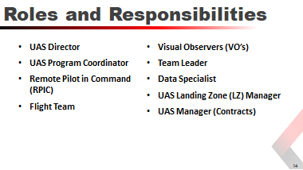
UAS Director | Resolve conflicts or disputes that might arise related to policy or mission within their division.  Establish protocols to prevent violations of policy, law, and public privacy.  Control the dissemination of any information produced by the divisions UAS team.  Designate the UAS Program Coordinator.  Shall be ultimately responsible for his/her divisions reporting requirements under Texas Government Code 423.
UAS Program Coordinator | Responsible for assisting in the tactical and administrate functions related to the UAS program including maintaining a current list of all certified crew members to include RPIC’s and Visual Observers.  Responsible for maintaining the training records for crew members and compliance with TX Gov. Code 423 reporting.  Responsible for the condition, maintenance and flight records of the UAS and associated equipment.
Remote Pilot in Command (RPIC) | Mission commander with on-site authority for the UAS  Solely responsible for the overall flight operations for a specific mission.  May only operate one UAS at a time.  Each UAS shall have its own RPIC assigned.
Flight Team | Any combination of the RPIC and Visual Observer(s).  ONLY the RPIC meets the FAA definition of crewmember.
Visual Observers (VO’s) | Individual trained to maintain line of sight and 360 degree hazard awareness around the UAS at all times.  May be formally trained and certified for special operations or chosen ad hoc and properly briefed by the RPIC.
Team Leader | A UAS Team Leader is a supervisory position.  This position leads a group of RPIC’s/VO’s, LZ Managers, Data Specialists or other crew members.  The Team Leader’s tactical responsibilities may also include but are not limited to the overseeing and managing of the following:  - Airspace Assurance Standards (in absence of LZ Manager)  - Liaison with IC / UAS Branch  - Assuming LZ Manager duties
Data Specialist | This position collects, stores, and disseminates UAS collected data. This position specializes in converting video, still, or telemetry data into either a pre-processed dataset or precision product such as geo-referenced maps, ortho photos, digital elevation models, or 3D terrain models.  Works as a team member with the RPIC to generate data required for strategic level planning, assessment, or decision-making tools.
UAS Landing Zone (LZ) Manager | Personnel assigned responsible landing zone operations. LZ Manager is required position anytime there are three or more aircraft flying from the same landing/takeoff zone.  Manages air traffic landing / takeoff operations and airspace assurance standards  The LZ Manager will receive mission assignments and assign those missions to the appropriate pilots.
UAS Manager (Contracts) | Conduit between a UAS vendor (under federal contract/agreement) and an Incident Management Team (IMT). The UAS Manager coordinates vendor UAS missions with operations, air operations, and planning personnel and is the designated government official (ACOR/PI) for the UAS contract/agreement.  Coordinates contract UAS operations with the air operations branch, planning section, participating aircraft, aerial supervision, and ground personnel. This position is activated when contract UAS services are requested for an incident.
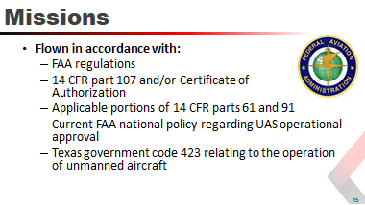
All missions will be flown in accordance with FAA regulations, 14 CFR parts 107 and/or Certificate of Authorization, applicable portions of 14 CFR parts 61 and 91, current FAA national policy regarding UAS operational approval, and Texas government code 423 relating to the operation of unmanned aircraft.
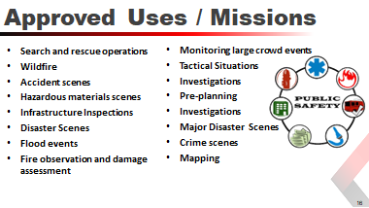
All UAS mission requests shall be authorized by the PSURT Duty Officer (or designee). Missions include, but are not limited to:
- Search and rescue operations  - Wildfire  - Accident scenes  - Hazardous materials scenes  - Infrastructure Inspections | - Disaster Scenes  - Flood events  - Fire observation and damage assessment  - Monitoring large crowd events  - Tactical Situations | - Investigations  - Pre-planning  - Investigations  - Major Disaster Scenes  - Crime scenes  - Mapping
Other case by case missions may be approved if those missions are immediately necessary. Consideration will be based on life safety, incident stabilization, and property conservation.
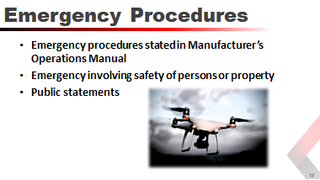
You must comply with all emergency procedures stated in the manufacturer’s operations manual for all UAS operations. In the event of an emergency involving the safety of persons or property, the RPIC may deviate from the procedures of this directive relating to aircraft, equipment, and weather minimums to the extent required for the emergency.
No member of the department, regardless of involvement in an emergency situation, shall make any statements to the general public or to news-gathering agencies without the knowledge and approval through the Public Information Office (PIO) of the affected Jurisdiction.
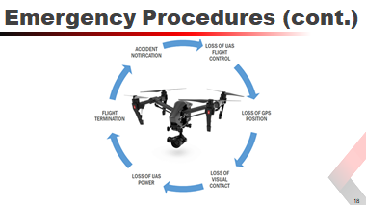
Loss of UAS Flight Controls | An interruption or loss of command and control link contact with the UAS such that the RPIC can no longer manage the aircraft’s flight and, as a result, the aircraft is no longer operating in a predictable or planned manner.
Loss of GPS Position | Should the UAS lose GPS signal during autonomous operations, the RPIC must immediately take command of the UAS and land as soon as practical.
Loss of Visual Contact | If visual contact with the UAS is lost, the RPIC shall take command of the aircraft and place it into a hover. The RPIC and/or Visual Observer shall try to reestablish visual contact.
Loss of UAS Power | In case of an engine or battery failure, the UAS will not be able to maintain flight. Flight team members will immediately attempt to locate the UAS, assess the scene for injuries and render first aid if necessary.
Flight Termination | Flight termination must be executed in the event that all other contingencies have been exhausted and further flight of the UAS cannot be safely achieved or other potential hazards exist that require immediate discontinuation of flight.
Accident Notification | The RPIC must report to the FAA within 10 days of any accident that results in at least serious injury, loss of consciousness or property damage of at least $500.
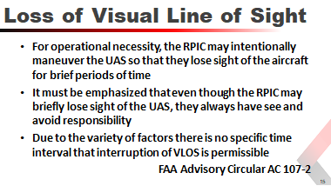

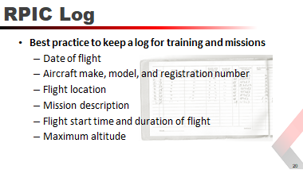
You can use an online log that imports your flights directly from the flight software, and/or a paper log.
The advantage of having a paper log available is that, when the FAA conducts a ramp check, you can hand over the paper log. If you only have an electronic version, you may have to hand over your phone or iPad.
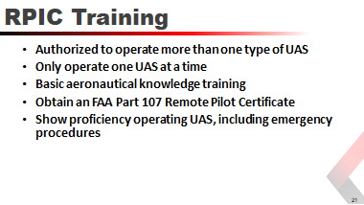
The RPIC shall show proficiency in basic aeronautical knowledge as it relates to the use and operation of UAS assets. The RPIC shall pass an initial aeronautical knowledge test at an FAA-approved knowledge testing center or comply with the 14 CFR Part 107 protocols for a licensed and current 14 CFR Part 61 RPIC.
The basic aeronautical knowledge training, at a minimum shall include:
- FAA rules pertaining to UAS flight operational limitations
- All aspects of 14 CFR Part 107
- Knowledge of the rules and responsibilities described in 14 CFR 91
- All aspects of Texas Government Code 423
- Crew Resource Management
- Mission planning requirements for establishing the Mission AOR and Perimeter
- Mission briefing requirements to include approved checklists and Manufacturer’s recommendations
- Mission debriefing requirements
- Any other specific responsibilities required by the UAS Division Director.
An RPIC may be authorized to operate more than one type of UAS as long as he/she is trained and current in each individual model. He/she may only operate one UAS at a time.
The RPIC shall show proficiency operating the specific UAS model in flight including emergency procedures. The RPIC’s proficiency shall be evaluated by the UAS Program Coordinator or their designee who has mastered aeronautical knowledge and training as it pertains to the use of UAS assets.
The RPIC shall show proficiency with communications and crew resource management, and with flight team members demonstrating satisfactory communications between team members. The RPIC’s communications will be evaluated at all stages of the flight continuum: pre-flight inspection, flight operations, and post flight procedures.
The RPIC shall demonstrate proficiency in all the technology and support equipment associated with any assigned mission to take advantage of the full capabilities of the UAS.
Upon approval as a PSURT RPIC, the UAS Program Coordinator and or their designee shall prepare a letter of certification indicating that:
- The RPIC has demonstrated proficiency operating UAS assets
- The RPIC has met all training requirements to operate UAS assets
- The RPIC is authorized to operate UAS assets while carrying out his/her duties in an official capacity.
The letter of certification shall be submitted to the employee’s supervisor and UAS Director for final approval. Copies of the certification shall be sent to the RPIC and filed in her/his electronic personnel file and retained by the UAS Program Coordinator.
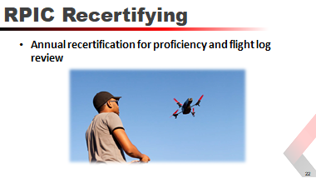
Each certification is valid for one year from the date of the test, at which time the RPIC must recertify on each aircraft they fly. The recertification is a one-day class that includes ground school and a hands-on flight test.
- Ground school covers rules and regulations that have changed in the past year, as well as new and revised best practices learnt in the field. In addition, the RPIC is required to pass a written test similar to the recurrent Part 107 test that includes questions about airspace, maps, weather, mission planning, FAA rules and regulations, among other topics. Both Level 1 and Level 2 RPIC’s complete the test; however, there is an additional section in the test for Level 2 RPIC’s to complete that covers night operations.
- The hands-on flight test is scenario-based using one or more of the scenarios in the Level 1 or Level 2 training courses.

Mission Planning
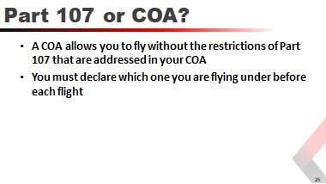

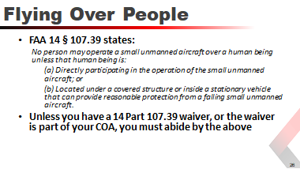

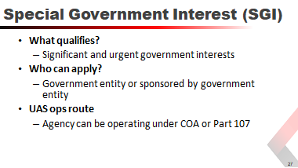
You need a Special Government Interest (SGI) if your operation falls into the “Significant and urgent government interests” category, that is, if any part of your proposed UAS operations site relates to one or more of the following:
- National defense
- Homeland security
- Law enforcement
- Emergency operations (critical infrastructure)
Requested operations must be flown by a government entity or sponsored by a government entity. The agency may be operating under an active COA or Part 107.
How to Apply
The Systems Operations Support Center (SOSC) can be reached 24/7 at:
FAA System Operations Support Center (SOSC)
Contact number: 202.267.8276
Email Address: 9-ATOR-HQ-SOSC@faa.gov
When you contact them, provide the following information:
- Approval to conduct a UAS operation in <restricted airspace>.
- The name of the government agency and contact information for the person who has granted approval for the UAS operation.
The turnaround time for granting an SGI is ~30-60 minutes after the form has been received by SOSC. However, if the request is for a safety of life op or a law enforcement op where the UAS op needs to start immediately, an SGI can be granted over the phone before all the paperwork has been processed.
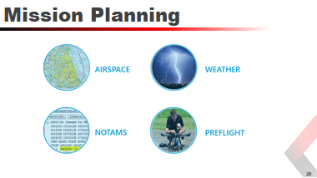
Airspace | National Airspace Systems (NAS) established in 1958 by the Federal Aviation Administration.
Weather | The state of the atmosphere at a place and time as regards heat, dryness, sunshine, wind rain, and so on.
NOTAMS | A written notification issued to RPIC’s before a flight, advising them of circumstances relating to the state of flying.
Preflight | A series of checks and inspections of all equipment, environment and personnel.

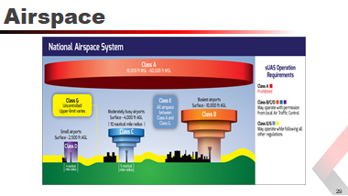
The NAS is made up of a network of air navigation facilities, ATC facilities, airports, technology, and appropriate rules and regulations that are needed to operate the system.
The FAA created the National Airspace System (NAS) to protect persons and property on the ground, and to establish a safe and efficient airspace environment for civil, commercial, and military aviation.
Class | Height | Description
Class A | 18,000 - 60,000 ft. MSL | UAS prohibited in this airspace
Class B | Surface - 10,000 ft. AGL | High-density airports  Designed to regulate flow  Varying altitudes  Must have permission
Class C | Surface - 4,000 ft. AGL | Moderately busy airports  5 - 10 nautical mile radius
Class D | Surface - 2,500 ft. AGL | Local air traffic control tower  Sequences traffic  No separation services  4 nautical mile radius  Must have permission
Class E | 700/1,200 ft. AGL – 18,000 | All airspace between Class A and Class G.  Fills gaps between B, C, D airspace  Sequences traffic  No separation services  Regulations allow flight
Class G | Surface - Varies | Uncontrolled airspace  Upper limit varies  Most UAS flying done here  Must follow Part 107/COA

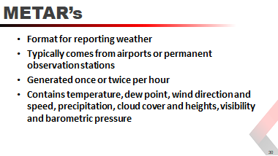
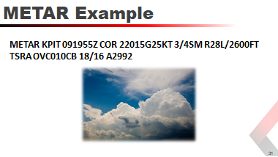
METAR KPIT 091955Z COR 22015G25KT 3/4SM R28L/2600FT TSRA OVC010CB 18/16 A2992
KPIT | Location
091955Z | Two-digit date; four-digit time. Therefore, this example is the 9th at 1955 Zulu.
COR | A corrected observation or AUTOmated observation for automated report with no human intervention.
22015G25KT | Wind: 3-digit true north wind direction to the nearest 10 degrees. Next 2-3 digits is speed and unit (KT = knots per second). G = gusts and maximum speed and unit; therefore, gusting to 25 knots. If direction varies 60 degrees or more, V is used for variable.
3/4SM | Visibility in statue miles and fractions; therefore ¾ of a statute mile. If visibility is greater than 6 miles, TAF displays P6SM.
R28L/2600FT | Runway visual range: 2-digit runway designator with Left, Center, Right as needed. 4-digit value in feet.
TSRA | Significant present, forecast and recent weather.
OVC010CD | Cloud amount in height and type. Overcast at 1,000 feet; CumulonimBus clouds.
18/16 | Temperature in degrees Celsius. First 2 digits are temperature; last two digits are dew point temperature.
A2992 | Altimeter indicator: A = inches and hundredths; Q = hectoPascals

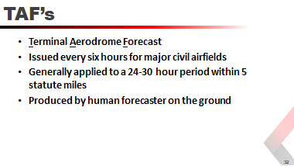
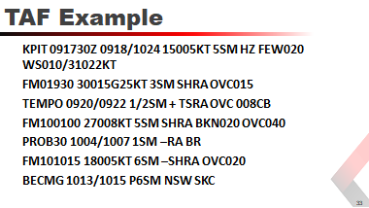
KPIT 091730Z 0918/1024 15005KT 5SM HZ FEW020 WS010/31022KT
FM01930 30015G25KT 3SM SHRA OVC015
TEMPO 0920/0922 1/2SM + TSRA OVC 008CB
FM100100 27008KT 5SM SHRA BKN020 OVC040
PROB30 1004/1007 1SM –RA BR
FM101015 18005KT 6SM –SHRA OVC020
BECMG 1013/1015 P6SM NSW SKC

KPIT | Location
091730Z | Two-digit date; four-digit time. Therefore, in this example, it is the 9th at 1730 Zulu.
0918/1024 | Valid period. First two digits of each 4-digit number indicate the date of the valid period. The last two digits indicate time. Therefore valid from 18Z on the 9th through 24Z on the 10th.
15005KT | Wind coming from 150 degrees at 5 knots
5SM | Visibility in statue miles and fractions; therefore 5 statute miles. If visibility is greater than 6 miles, TAF displays P6SM.
HZ | Significant present, forecast and recent weather.
FEW020 | Cloud amount in height and type. Few clouds at 2,000 feet.
WS010/31022KT | Nonconvective low-level Wind Sheer; 3-digit height; 3-digit wind direction; 2-3 digit wind speed and the unit. Therefore, wind sheer at 1,000 feet from 310 degrees at 22 knots.

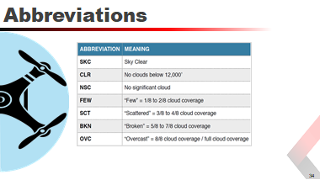
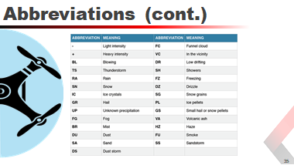

SKC | Sky Clear | BR | Mist
CLR | No clouds below 12,000’ | DU | Dust
NSC | No significant cloud | SA | Sand
FEW | “FEW” = 1/8 to 2/8 cloud coverage | DS | Dust Storm
SCT | “Scattered” = 3/8 – 4/8 cloud coverage | FC | Funnel Cloud
BKN | “Broken” = 5/8 – 7/8 cloud coverage | VC | In the vicinity
OVC | “Overcast” = 8/8 cloud coverage / full cloud coverage | DR | Low drifting
- | Light intensity | SH | Showers
+ | Heavy intensity | FZ | Freezing
BL | Blowing | DZ | Drizzle
TS | Thunderstorm | SG | Snow grains
RA | Rain | PL | Ice pellets
SN | Snow | GS | Small hail or snow pellets
IC | Ice Crystals | VA | Volcanic ash
GR | Hail | HZ | Haze
UP | Unknown Precipitation | FU | Smoke
FG | Fog | SS | Sandstorm

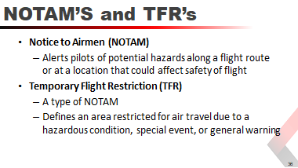

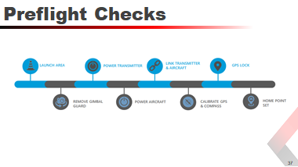
Launch Area | Make sure that you take off from a clean and stable surface, and not from sand or an excessively dirty area as the camera and motors could be damaged once the aircraft starts up.
Gimbal Guard | Remove the gimbal guard to ensure that the gimbal can move freely.
Transmitter | Turn on the transmitter and ensure that it remains powered up and has a full charge.
Aircraft | Ensure aircraft battery is fully charged before powering up. Once powered up, ensure that the aircraft remains powered up and hasn’t turned itself off inadvertently during power up.
Link | Ensure that a link has been established between the transmitter and aircraft. If no connection, power off both the transmitter and aircraft, power up the transmitter first, and then the aircraft to remedy the problem.
Calibrate | Calibrate the GPS and compass by rotating the aircraft on its axis, keeping the aircraft in the center while you move around it.
GPS Lock | Ensure that there is a GPS lock and compass calibration via LED light sequence, or indication on video display. Unless flying indoors, do not take off without GPS lock. TIP: If you are not getting a GPS lock, it sometimes finds a lock if you take off and hover 2-3 feet above the ground.
Home Point | Make sure that the home point has been set post GPS and compass calibration and before flight. Failure to do so will result in a “fly-away” if transmitter and aircraft become disconnected.

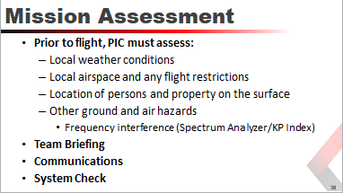
Prior to flight, the RPIC must assess the environment, including:
- Local weather conditions
Hot/cold weather affects controllers and batteries.
Icing can be a problem. Watch for icing on props and, when flying, listen for changes in pitch which may indicate icing.
- Local airspace and any flight restrictions
- The location of persons and property on the surface
- Other ground and air hazards
Cell towers
Manned aircraft
Birds (TIP: Birds of prey can dive fast but they cannot climb fast so climb to get away from them.)
Hot air balloons & gliders
Possible frequency Interference
Team Briefing - Ensure that all crew members are informed about the operating conditions, emergency procedures, contingency procedures, roles and responsibilities, and potential hazards.
Communications - Ensure that all control links between ground control station and the aircraft are working properly.
Systems Check - Ensure that there is enough available power for the UAS to operate for the mission.
Payload Check - Ensure that any payload attached to the UAS is secure and does not adversely affect the flight characteristics or controllability of the aircraft.
Study the mission area, and conduct a site survey to look for any obstructions, nearby airports, and helipads, or restricted airspace.
You must determine that unless authorized, you are not flying near an airport or helipad, aren’t in restricted airspace, and have confirmed there are no obstructions that could cause a flight safety hazard before proceeding with the mission.
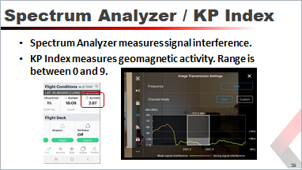
A spectrum analyzer measures signal interference. The higher the interference, the more chance there is that you may encounter signal loss or intermittent video.
The KP Index measures geomagnetic activity. Range is between 0 and 9. The higher the number, the more chance of you running into problems with signal or video degradation or loss.
Check that these numbers are within safe parameters before each flight.
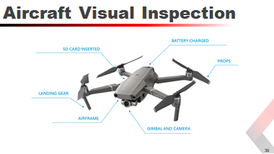

Battery Charged | Check all batteries independently to ensure that they are fully charged and ready for flight.
Props | Check the props to make sure they are properly secured to the aircraft and free from cracks or lines that could indicate an imminent crack.
Gimbal and Camera | Check that the camera is properly attached to the gimbal and that there isn’t anything loose. Also make sure that the gimbal is properly secured to the aircraft and all dampers are attached and free of any debris.
Airframe | Check that all screws are tight, and that the aircraft is free from any dirt and debris that could throw off its center of balance. Bug splatter is normal but still should be wiped clean before and after every flight.
Landing Gear | Check that the landing gear is rigid, and secured to the aircraft. Make sure all connection screws are tight.
SD Card Inserted | Make sure that the SD card is of the correct class, is inserted properly, and has enough free space on it to record all mission data including photos and video.

Night Operations
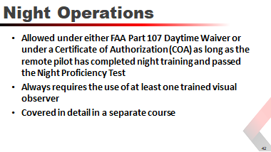
Night operations have unique challenges that require an understanding of how vision works at night as well as an increased understanding of the hazards and dangers involved.
It is recommended to complete several hours of daytime flights before attending the Night Operations (Level 2) course.

FAA Law Enforcement Assistance Program (LEAP)
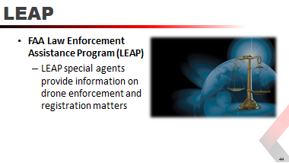
“The Law Enforcement Assistance Program (LEAP) consists of field investigative and operational activities that support federal, state, and local agencies by denying anyone who would threaten national security access to the National Airspace System.
They take regulatory enforcement actions and, as appropriate, provide aviation-related support to law enforcement agencies seeking criminal prosecution or conducting airborne drug interdiction. Agents also provide training to law enforcement officers in aviation smuggling techniques and FAA resources.
Special agents from the FAA's Law Enforcement Assistance Program (LEAP) are your point of contact for federal, state, local, tribal, territorial and international law enforcement agencies. LEAP special agents can provide information on drone enforcement and registration matters. Providing a LEAP special agent with reports of suspected unauthorized UAS incidents in a timely manner increases the FAA's ability to take enforcement action when appropriate. NOTE: You may contact any LEAP agent if your assigned agent is not available.
For further information on contacting a LEAP agent email UAShelp@faa.gov or call 844-FLY-MY-UA.
- FAA LEAP Webpage

Texas Government Codes
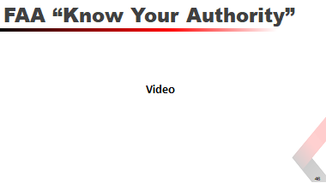

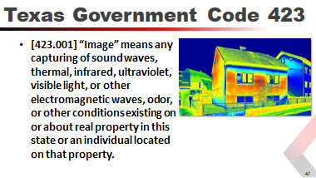

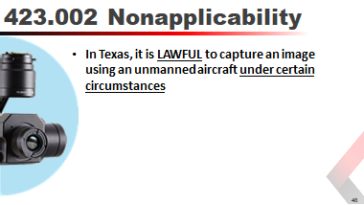
423.002
For purposes of professional or scholarly research and development by a person acting on behalf of an institution of higher education, as defined by Section 61.003, Education Code, including a person who:
is a professor, employee, or student of the institution; or
is under contract with or otherwise acting under the direction or on behalf of the institution;
in airspace designated as a test site or range authorized by the Federal Aviation Administration for the purpose of integrating unmanned aircraft systems into the national airspace;
as part of an operation, exercise, or mission of any branch of the United States military;
if the image is captured by a satellite for the purposes of mapping;
if the image is captured by or for an electric or natural gas utility:
for operations and maintenance of utility facilities for the purpose of maintaining utility system reliability and integrity;
for inspecting utility facilities to determine repair, maintenance, or replacement needs during and after construction of such facilities;
for assessing vegetation growth for the purpose of maintaining clearances on utility easements; and
for utility facility routing and siting for the purpose of providing utility service;
with the consent of the individual who owns or lawfully occupies the real property captured in the image;
pursuant to a valid search or arrest warrant;
if the image is captured by a law enforcement authority or a person who is under contract with or otherwise acting under the direction or on behalf of a law enforcement authority:
in immediate pursuit of a person law enforcement officers have reasonable suspicion or probable cause to suspect has committed an offense, not including misdemeanors or offenses punishable by a fine only;
for the purpose of documenting a crime scene where an offense, not including misdemeanors or offenses punishable by a fine only, has been committed;
for the purpose of investigating the scene of:
a human fatality;
a motor vehicle accident causing death or serious bodily injury to a person; or
any motor vehicle accident on a state highway or federal interstate or highway;
in connection with the search for a missing person;
for the purpose of conducting a high-risk tactical operation that poses a threat to human life; or
of private property that is generally open to the public where the property owner consents to law enforcement public safety responsibilities;
if the image is captured by state or local law enforcement authorities, or a person who is under contract with or otherwise acting under the direction or on behalf of state authorities, for the purpose of:
surveying the scene of a catastrophe or other damage to determine whether a state of emergency should be declared;
preserving public safety, protecting property, or surveying damage or contamination during a lawfully declared state of emergency; or
conducting routine air quality sampling and monitoring, as provided by state or local law;
at the scene of a spill, or a suspected spill, of hazardous materials;
for the purpose of fire suppression;
or the purpose of rescuing a person whose life or well-being is in imminent danger;
if the image is captured by a Texas licensed real estate broker in connection with the marketing, sale, or financing of real property, provided that no individual is identifiable in the image;
of real property or a person on real property that is within 25 miles of the United States border;
from a height no more than eight feet above ground level in a public place, if the image was captured without using any electronic, mechanical, or other means to amplify the image beyond normal human perception;
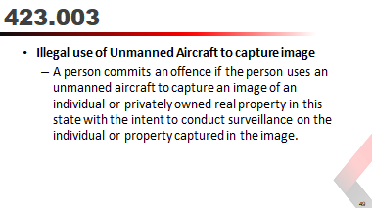
An offense under this section is a Class C misdemeanor.
It is a defense to prosecution under this section that the person destroyed the image:
as soon as the person had knowledge that the image was captured in violation of this section; and
without disclosing, displaying, or distributing the image to a third party.
In this section, “intent” has the meaning assigned by Section 6.03, Penal Code.
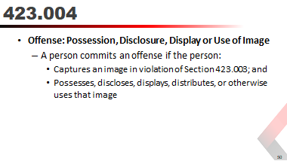
An offense under this section for the possession of an image is a Class C misdemeanor. An offense under this section for the disclosure, display, distribution, or other use of an image is a Class B misdemeanor.
Each image a person possesses, discloses, displays, distributes, or otherwise uses in violation of this section is a separate offense.
It is a defense to prosecution under this section for the possession of an image that the person destroyed the image as soon as the person had knowledge that the image was captured in violation of Section 423. 003.
It is a defense to prosecution under this section for the disclosure, display, distribution, or other use of an image that the person stopped disclosing, displaying, distributing, or otherwise using the image as soon as the person had knowledge that the image was captured in violation of Section 423.003.
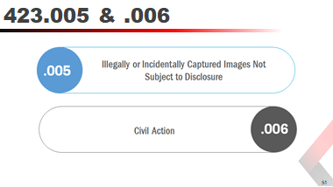
423.005
Except as otherwise provided by Subsection (b), an image captured in violation of Section 423.003, or an image captured by an unmanned aircraft that was incidental to the lawful capturing of an image:
may not be used as evidence in any criminal or juvenile proceeding, civil action, or administrative proceeding;
is not subject to disclosure, inspection, or copying under Chapter 552; and
is not subject to discovery, subpoena, or other means of legal compulsion for its release.
An image described by Subsection (a) may be disclosed and used as evidence to prove a violation of this chapter and is subject to discovery, subpoena, or other means of legal compulsion for that purpose.
423.006
An owner or tenant of privately owned real property located in this state may bring against a person who, in violation of Section 423.003, captured an image of the property or the owner or tenant while on the property an action to:
enjoin a violation or imminent violation of Section 423.003 or 423.004;
recover a civil penalty of:
$5,000 for all images captured in a single episode in violation of Section 423.003; or
$10,000 for disclosure, display, distribution, or other use of any images captured in a single episode in violation of Section 423.004; or
recover actual damages if the person who captured the image in violation of Section 423.003 discloses, displays, or distributes the image with malice.
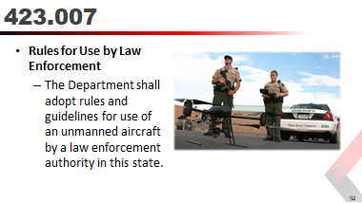

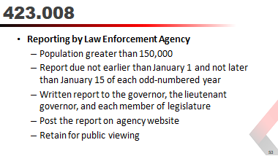
Not earlier than January 1 and not later than January 15 of each odd-numbered year, each state law enforcement agency and each county or municipal law enforcement agency located in a county or municipality, as applicable, with a population greater than 150,000, that used or operated an unmanned aircraft during the preceding 24 months shall issue a written report to the governor, the lieutenant governor, and each member of the legislature and shall:
- Retain the report for public viewing; and
- Post the report on the law enforcement agency's publicly accessible website, if one exists.
This report must include:
- The number of times an unmanned aircraft was used, organized by date, time, location, and the types of incidents and types of justification for the use;
- The number of criminal investigations aided by the use of unmanned aircraft and a description of how the unmanned aircraft aided each investigation;
- The number of times an unmanned aircraft was used for a law enforcement operation other than a criminal investigation, the dates and locations of those operations, and a description of how the unmanned aircraft aided each operation;
- The type of information collected on an individual, residence, property, or area that was not the subject of a law enforcement operation and the frequency of the collection of this information; and
- The total cost of acquiring, maintaining, repairing, and operating or otherwise using each unmanned aircraft for the preceding 24 months.

Case Law
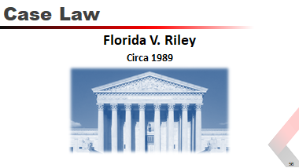
Florida V. Riley (Circa 1989)
The Pasco County Sheriff's Office received a tip that Michael Riley was growing marijuana on his 5 acres (20,000 m²) of rural property. A deputy sheriff subsequently investigated the tip and went to Riley's mobile home.
Unable to see inside a greenhouse, which was behind the defendant's mobile home, the deputy circled over the property using a helicopter. The absence of two roof panels allowed the deputy to see, with his naked eye, what appeared to be marijuana growing.
A warrant was obtained and marijuana was found inside the greenhouse.
Riley successfully argued before the trial court that the aerial search violated his reasonable expectation of privacy and Fourth Amendment rights.
The Court of Appeals disagreed, siding instead with the state, but the Florida Supreme Court agreed with Riley and overturned the Court of Appeals.
Key Facts
- Florida v. Riley, 488 U.S. 445 (1989)
- Argued October 3, 1988
- Decided January 23, 1989
- Chief Justice William Rehnquist, Associate Justices William J. Brennan, Jr., Byron White, Thurgood Marshall, Harry Blackmun, John P. Stevens, Sandra Day O’Connor, Antonin Scalia, Anthony Kennedy
- Laws applied: U.S. Constitution, Amendment 4
- Holding: Helicopter surveillance at an altitude of 400 feet did not constitute a search under the Fourth Amendment. Florida Supreme Court reversed.
- Decision: United States Supreme Court held that police officials do not need a warrant to observe and individual’s property from public airspace at an altitude of 400 feet.
Decision and Rationale
The Supreme Court reversed the decision of the Florida Supreme Court with a four-vote plurality, arguing that the accused did not have a reasonable expectation that the greenhouse was protected from aerial view, and thus that the helicopter surveillance did not constitute a search under the Fourth Amendment.
However, the Court stopped short of allowing all aerial inspections of private property, noting that it was "of obvious importance" that a private citizen could have legally flown in the same airspace:
Any member of the public could legally have been flying over Riley's property in a helicopter at the altitude of 400 feet and could have observed Riley's greenhouse. The police officer did no more.
Also vital to the Court's ruling was the fact that the helicopter did not interfere with the normal use of the property:
As far as this record reveals, no intimate details connected with the use of the home or curtilage were observed, and there was no undue noise, no wind, no dust, or threat of injury. In these circumstances, there was no violation of the Fourth Amendment.
“Whether surveillance of the interior of a partially covered greenhouse in a residential backyard from the vantage point of a helicopter located 400 feet (120 m) above the greenhouse constitutes a 'search' for which a warrant is required under the Fourth Amendment and Article I, 12 of the Florida Constitution."
- Justice White, quoting the Florida Supreme Court decision
Justice O’Connor (Concurrence)
Justice O'Connor felt that the plurality focused too much upon FAA regulations, "whose purpose is to promote air safety, not to protect [Fourth Amendment rights]." She deviated from the plurality opinion in arguing that the frequency of public flight in the airspace was a necessary concern, and that the mere legality of such flights was insufficient to determine whether the defendant had a reasonable expectation of privacy:
“It is not conclusive to observe, as the plurality does, that “any member of the public could legally have been flying over Riley's property in a helicopter at the altitude of 400 feet and could have observed Riley's greenhouse."
Nor is it conclusive that police helicopters may often fly at 400 feet.
If the public rarely, if ever, travels overhead at such altitudes, the observation cannot be said to be from a vantage point generally used by the public and Riley cannot be said to have "knowingly exposed" his greenhouse to public view.”
Justice Brennen (Dissent)
Justice Brennan, joined by Marshall and Stevens, strongly believed that the plurality had misstated the issue, agreeing with O'Connor that the frequency of public air travel was a necessary consideration, and that the key issue in the case was whether ordinary citizens were normally in the air above the defendant’s home:
“The police officer positioned 400 feet above Riley's backyard was not, however, standing on a public road. The vantage point he enjoyed was not one any citizen could readily share. His ability to see over Riley’s fence depended on his use of a very expensive and sophisticated piece of machinery to which few ordinary citizens have access.
However, Brennan disagreed with O'Connor in that he believed the defendant did not necessarily need to show that public flight was rare, but rather that the state needed to show that it was common:
Because the State has greater access to information concerning customary flight patterns and because the coercive power of the State ought not be brought to bear in cases in which it is unclear whether the prosecution is a product of an unconstitutional, warrantless search, the burden of proof properly rests with the State and not with the individual defendant. The State quite clearly has not carried this burden.”
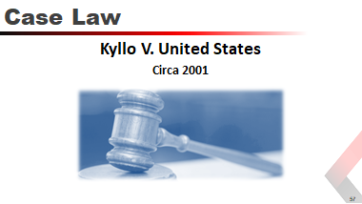
Kyllo V. United States
Kyllo v. United States revolves around a situation where the Department of the Interior used a thermal imaging device outside of the private residence of Danny Kyllo.
The evidentiary hearing in the District County Court stated that the imaging device could not penetrate the home’s walls or windows to reveal any human interactions or record any conversation. The device, upon use, showed that there was an unusual amount of heat radiating from the side walls and roof of the garage.
This information was ultimately used to obtain a search warrant where federal agents later discovered over 100 marijuana plants growing in Kyllo’s home.
Danny Kyllo was charged with growing marijuana in his Oregon residence. Kyllo appealed the charges in the Ninth Circuit Court by stating that the observations (obtained through the use of a thermal-imaging device) constituted a formal search under the Fourth Amendment.
Key Facts
- Kyloo v. United States, 533 U.S. 27 (2001)
- Argued February 20, 2001
- Decided June 11, 2001
- Chief Justice William Rehnquist, Associate Justices William J. Brennan, Jr., Byron White, Thurgood Marshall, Harry Blackmun, John P. Stevens, Sandra Day O’Connor, Antonin Scalia, Anthony Kennedy
- Laws applied: U.S. Constitution, Amendment 4
- Holding: Observations with a thermal-imaging device constituted a search under the Fourth Amendment.
- Decision: …the use of a thermal imaging device to monitor an individual’s home constitutes a Fourth Amendment “search” and may be accomplished only with the obtainment of a warrant.
Decision and Rationale
The Supreme Court ruled 5-4 that the thermal imaging of Kyllo's home constituted a search. Since the police did not have a warrant when they used the device, which was not commonly available to the public, the search was presumptively unreasonable and therefore unconstitutional. The majority opinion argued that a person has an expectation of privacy in his or her home and therefore, the government cannot conduct unreasonable searches, even with technology that does not enter the home.
Justice Scalia also discussed how future technology can invade on one's right of privacy and therefore authored the opinion so that it protected against more sophisticated surveillance equipment.
As a result, Justice Scalia asserted that the difference between "off the wall" surveillance and "through the wall" surveillance was non-existent because both methods physically intruded upon the privacy of the home.
Justice Stevens (Dissent)
In the dissent Justice John Paul Stevens argued that the use of thermal imaging does not constitute a search, which requires a warrant, because any person could detect the heat emissions.
He argued that this could be done by simply feeling that some areas in or around the house are warmer than others or observing that snow was melting more quickly on certain sections of the house.
Since the public could gather this information, Stevens argued, there is no need for a warrant and the use of this technique is not unconstitutional.
Moreover, Stevens asserted that the use of the thermal imaging device was merely "off-the-wall" surveillance because it did not detect any "intimate" details of Kyllo's home.
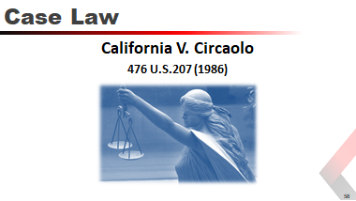
California V. Circaolo
Case decided by the United States Supreme Court, in which it ruled that warrantless aerial observation of a person's backyard did not violate the Fourth Amendment to the United States Constitution.
Background
Dante Carlo Ciraolo grew marijuana plants in his backyard, shielded from view by two fences.
After receiving an anonymous tip, the Santa Clara police sent officers in a private airplane to fly over and take aerial photographs of his property at an altitude of 1,000 feet. Based on an officer's naked eye observation, a search warrant was granted.
After the trial court rejected Ciraolo's motion to suppress the evidence (under the exclusionary rule), he pleaded guilty.
The California Court of Appeal reversed the decision, holding that the aerial observation was an intrusion into the curtilage of his home and therefore the Fourth Amendment.
Chief Justice Warren Burger
Chief Justice Warren Burger wrote for the 5-4 majority, referring to Katz v. United States. He concluded,
"The Fourth Amendment simply does not require the police traveling in the public airways at this altitude to obtain a warrant in order to observe what is visible to the naked eye."
Justice Powell (Dissent)
“the actual risk to privacy from commercial or pleasure aircraft is virtually nonexistent. Travelers on commercial flights, as well as private planes used for business or personal reason, normally obtain at most a fleeting, anonymous, and nondiscriminating glimpse of the landscape and buildings over which they pass.
The risk that a passenger on such a plane might observe private activities, and might connect those activities with particular people, is simply too trivial to protect against.“

Hands-On Training: Basic Flight

Setup
Students will receive instruction on, and demonstration of, the following:
- Preflight
- Visual Inspection
- Powering on the controller
- Powering on the UAS
- Connecting the controller to the flight display
- Overview of the software

Flight Hand Signals
Students should be taught the basic hand signals.
For hand signal examples, see Appendix C: Flight Hand Signals.

Basic Flight Maneuvers
After becoming familiar with the setup of the UAS, the students will be instructed in basic flight maneuvers: up, down, left, right, yaw left, yaw right, forward, and backward.

Using the Camera and Setting Flight Modes
Students will receive hands on instruction on:
- Camera Controls
- Exposure Settings
- Picture Taking
- Starting/Stopping Video Recording
- SD Card Management
- Flight modes (P, S, T) and RTH

Flight Time
Students will receive one hour of hands-on flight time practicing take offs, landings, and basic flight maneuvers.
Students shall start at 50 ft. AGL and climb to 400 ft. AGL in 50 foot increments, ensuring that they are comfortable at each altitude before continuing to the next.
Students shall be instructed to land the UAS with the tail of the aircraft facing them so that their stick movements correspond to the desired intent.

Test: Basic Flight Proficiency
For general objectives, see Curriculum Objectives.
Prior to beginning scenario based training, students will demonstrate their ability to safely and proficiently operate the UAS by completing the following without assistance:
- Set up the mission area and landing zone
- Perform a preflight inspection
- Power on the controller
- Power on the aircraft
- Connect the flight display and start the flight software
Students will receive 1.5 hours of flight time, demonstrating the ability to take off, land and perform basic flight maneuvers.
Students will conduct a series of flights at a variety of altitudes per the instructor’s directions.
Students will demonstrate the ability to adjust the camera controls, exposure setting, take a picture, start/stop a video and SD card management.
Students will demonstrate their understanding of the flight app, including:
- Heading Indication
- Artificial Horizon
- Distance to RPIC
- Direction to RPIC
- Camera Heading
- Camera Angle
- Camera Setting Menu
- System Setting Menu
- GPS indicator
- Battery Level Indicators
- Cloud Connection
- Map Settings

Hands-On Training: Scenario-Based
For scenario-based, mission planning, and in-flight emergency response objectives, see Curriculum Objectives.
This section includes five scenarios:
- Scenario 1: Search and Identify
Scenario 1a: Suspect (Law Enforcement)
Scenario 1b: HAZMAT Event (Emergency Response)
- Scenario 2: Persistent Situational Awareness
Barricaded Suspect (Law Enforcement)
Damage Assessment (Emergency Response)
- Scenario 3: Mapping / Photogrammetry
- Scenario 4: Overwatch / Indoor
- Scenario 5: Search and Rescue

Scenario 1a: Search and Identify (Law Enforcement)

 | Suspect
Props: |  | Vehicle, License Plates, Gun, Hat, Evidence
Flight Time: |  | Each student RPIC should get 1.5 hours of flight time during the scenario.
Scenario: |  | An armed bank robbery suspect traveled down a dirt road. The suspect stopped the vehicle, exited, and continued on foot through the brush. The ground unit believes the suspect threw items from the vehicle before exiting. A UAS team is deployed to locate the vehicle and identify any evidence.
Student Actions: |  | - Two student RPIC’s launch from the designated coordinates and travel down the dirt road.  - RPIC #1 maintains an altitude just above tree level,  - RPIC #2 maintains an altitude a minimum of 100 feet above RPIC #1.  - Coordinating their efforts, the student RPIC’s attempt to locate the suspects’ vehicle.  - RPIC #1 decreases altitude and identifies the vehicle and license plate. After the vehicle identification is completed, RPIC #1 clears the vehicle then conducts a search of the surrounding area for evidence.  - RPIC #2 continues to maintain a minimum altitude of 100 feet above RPIC #1 and assist with coordinating the search.  - Non flying students fill the role of visual observers. VO’s simulate utilizing the UAS radio channel to relay pertinent information back to command. If flight crew is enabled using DroneSense, VO’s shall demonstrate the ability to access the flight software Ops Center for viewing of video streaming and to assist with airspace deconfliction.
Expectations: |  | Students are expected to demonstrate the ability to effectively communicate and coordinate activities.  Students will identify the primary (#1) RPIC and the secondary (#2) RPIC.  Students will demonstrate the ability to properly maintain a safe altitude from each other.  Utilizing the onboard camera, students will demonstrate the ability to perform a search for a vehicle and the ability to position the UAS where the license plate is identifiable.  Students will demonstrate the ability to conduct a low altitude flight, flying “low and slow” to identify evidence.
After Action: |  | After all criteria have been met, both RPIC’s safely land their aircraft and discuss the scenario with the instructor. Each student is required to be the primary and secondary RPIC in this scenario.

Scenario 1b: Search and Identify (Emergency Response)

 | HAZMAT Event
Props: |  | Pickup truck and / or trailer capable of carrying 55 gallon drums and / or a hazardous material tote(s), a structure / building, a mannequin, HAZMAT placards, smoke machine (generator or power source is required), and liquid to simulate spill or release.
Flight Time: |  | Each student RPIC should get 1.5 hours of flight time during the scenario.
Scenario: |  | It’s believed that a vehicle transporting hazardous material has been abandoned next to a home suspected of drug manufacturing. A neighbor reported “a loud explosive sound, weird smell, and smoke coming from the containers on the vehicle / trailer.” A UAS team is called to search and identify the area while providing a damage assessment to the Incident Commander. A primary and secondary search of the area of operation is very important to communicate to Command and the incoming HAZMAT response team.
Student Actions: |  | - Two student RPIC’s launch from the designated coordinates fly to designated point of interest.  - RPIC #1 maintains an altitude just above tree level,  - RPIC #2 maintains an altitude a minimum of 100 feet above RPIC #1.  - Coordinating their efforts, the student RPIC’s attempt to locate the designated point of interest.  - RPIC #1 decreases altitude and identifies the vehicle, license plate, HAZMAT vessels / placards, and damage associated with the incident. After the vehicle identification and scene assessment, RPIC #1 clears the exterior of the structure for any additional damage or safety concerns for ground crews.  - RPIC #2 continues to maintain a minimum altitude of 100 feet above RPIC #1 and assist with coordinating the search.  - Non flying students fill the role of visual observers. VO’s simulate utilizing the UAS radio channel to relay pertinent information back to command. If flight crew is enabled using DroneSense, VO’s shall demonstrate the ability to access the flight software Ops Center for viewing of video streaming and to assist with airspace deconfliction.
Expectations: |  | Students are expected to demonstrate the ability to effectively communicate and coordinate activities.  Students will identify the primary (#1) RPIC and the secondary (#2) RPIC.  Students will demonstrate the ability to properly maintain a safe altitude from each other.  Utilizing the onboard camera, students will demonstrate the ability to perform a search of the scene and the ability to position the UAS where the point of interest is identifiable.  Students will demonstrate the ability to conduct a low altitude flight, flying “low and slow” to identify evidence.
After Action: |  | After all criteria have been met, both RPIC’s safely land their aircraft and discuss the scenario with the instructor. Each student is required to be the primary and secondary RPIC in this scenario.

Scenario 2a: Persistent Situational Awareness (Law Enforcement)

 | Barricaded Suspect
Props: |  | Full body cut out, half body cut out, random weapons
Flight Time: |  | Each student RPIC should receive 1.5 hour of flight time during the scenario
Scenario: |  | Two armed barricaded suspects in the building, location unknown, motive unknown, weapon types unknown. UAS team deployed to conduct perimeter search and to identify the location and description of the shooter.
Student Actions: |  | Two student RPIC’s launch from the front of the building and coordinate a detailed perimeter search of the building from multiple altitudes. RPIC’s will search the exterior and the roof of the building to potentially identify additional suspects. Once perimeter search has been conducted, RPIC #1 shall attempt to locate the suspects and provide a description and location. RPIC #2 shall remain a safe altitude above RPIC #1 and provide an aerial view of the situation. RPIC’s shall identify entry and exit points to the building.  Non flying students will fill the role of visual observers. VO’s simulate utilizing the UAS radio channel to relay pertinent information back to command. If flight crew is enabled using DroneSense, VO’s shall demonstrate the ability to access the flight software Ops Center for viewing of video streaming and to assist with airspace deconfliction.
Expectations: |  | Students are expected to demonstrate the ability to effectively communicate and coordinate activities.  Students will identify the primary (#1) RPIC and the secondary (#2) RPIC.  Students will demonstrate the ability to properly maintain a safe altitude from each other.  Utilizing the onboard camera, students will demonstrate the ability to perform an aerial observation of the perimeter of the building and the roof, identify entry/exit points and identify additional suspects.  RPIC #1 is expected to demonstrate the ability to determine the shooters location and provide a description.
After Action: |  | After all criteria have been met, both RPIC’s safely land their aircraft and discuss the scenario with the instructor. Each student is required to be the primary and secondary RPIC in this scenario.

Scenario 2b: Persistent Situational Awareness (Emergency Response)

 | Damage Assessment – Disaster Response (Flood, High Winds, Damage to Structural Integrity)
Props: |  | Structure with utility service (meter, overhead wires, service drop), 2-3 simulated power poles (vertical 4x4 post with 2x4 cross member), rope to simulate wires, vehicle(s), smoke machine (generator or power source required), mannequin(s), debris to include at least two pieces of sheet metal / corrugated roofing, broken plexiglass, toys, and so on.
Flight Time: |  | Each student RPIC should receive 1.5 hour of flight time during the scenario
Scenario: |  | A storm with high winds and excessive rain has affected a rural community. High flood waters have compromised road access and boat teams have been deployed to affect rescue. Incident Command is looking for aerial assessments in order to prioritize boat team response and provide AHJ with damage assessment of properties.
Student Actions: |  | Two student RPIC’s will launch from access point remote from structure (at least 300’) and coordinate at multiple altitudes a primary and secondary search of the structure and affected property. After the primary search has been conducted, RPIC #1 shall attempt to locate the victims and relay any life safety or property conservation concerns to Command. RPIC #2 shall remain at a safe altitude above RPIC #1 and provide an aerial overview of the affected area. RPIC’s shall work together to identify hazards associated with response (disaster victims, affected utilities such as downed power lines, damage to structural integrity, fire, and so on)  Non flying students will fill the role of visual observers. VO’s simulate utilizing the UAS radio channel to relay pertinent information back to Command. If flight crew is enabled using DroneSense, VO’s shall demonstrate the ability to access the flight software Ops Center for viewing of video streaming and to assist with airspace deconfliction.
Expectations: |  | Students are expected to demonstrate the ability to effectively communicate and coordinate activities.  Students will identify the primary (#1) RPIC and the secondary (#2) RPIC.  Students will demonstrate the ability to properly maintain a safe altitude from each other.  Utilizing the onboard camera, students will demonstrate the ability to perform an aerial observation of the building and property and identify life safety concerns and hazards.  RPIC #1 is expected to demonstrate the ability to perform both a primary and secondary search to locate victim(s) and provide Command pertinent information for future response.
After Action: |  | After all criteria have been met, both RPIC’s safely land their aircraft and discuss the scenario with the instructor. Each student is required to be the primary and secondary RPIC in this scenario.

Scenario 3: Mapping / Photogrammetry

Props: | None
Flight Time: | Each student RPIC should get 1.5 hours of flight time during the scenario.
Scenario: | Mapping mission required of a specific area for later analysis. UAS team deployed to performing mapping mission and gain photos to upload to Pix4D.
Student Actions: | - Two student RPIC’s will prepare automated flight plans to successfully map the designated area(s).  Non flying students will fill the role of visual observers. VO’s will simulate utilizing the UAS radio channel to relay pertinent information back to Command. If flight crew is enabled using DroneSense, VO’s shall demonstrate the ability to access the flight software Ops Center for viewing of video streaming and to assist with airspace deconfliction.
Expectations: | Students are expected to demonstrate the ability to effectively create flight plans and apply proper camera angles to get the desired photos for upload into Pix4d.  Students will identify the primary (#1) RPIC and the secondary (#2) RPIC.  Students will demonstrate the ability to properly maintain a safe altitude from each other.
After Action: | After all criteria have been met, both RPIC’s safely land their aircraft and discuss the scenario with the instructor. Each student is required to be the primary and secondary RPIC in this scenario.

Scenario 4: Overwatch / Indoor

Props: | Suspect/hostage analog, various objects for identification.
Flight Time: | Each student RPIC should get 1.5 hours of flight time during the scenario.
Scenario: | Prior to warrant being served UAS team is deployed to perform perimeter search of the location and fly indoors to locate the suspect prior to entry by the SWAT team.
Student Actions: | - Prior to the start of the mission, the students conduct a mission brief to decide the best course of action to accomplish the objective.  - Two student RPIC’s launch from approximately 1/10 of a mile from the designated location.  - RPIC #1 positions in front of the primary entry point and RPIC #2 conducts the perimeter search.  - After the perimeter has been determined to be free of suspects, RPIC #1 enters the location and begins an interior search.  - RPIC #2 continues to provide overwatch of the location.  - Non flying students will fill the role of visual observers. VO’s will simulate utilizing the UAS radio channel to relay pertinent information back to Command. If flight crew is enabled using DroneSense, VO’s shall demonstrate the ability to access the flight software Ops Center for viewing of video streaming and to assist with airspace deconfliction.
Expectations: | Students are expected to demonstrate the ability to effectively communicate and coordinate activities. Students will identify the primary (#1) RPIC and the secondary (#2) RPIC. Students will demonstrate the ability to properly maintain a safe altitude from each other.  Utilizing the onboard camera, students will demonstrate the ability to perform an aerial observation of the location, the primary entry point, and any other areas designated by the instructor.  Students will demonstrate the ability to fly into an enclosed building through the large opening, through a doorway, and exit the building through a window.  Students will demonstrate the ability to adjust camera exposure levels to adjust to a variety of lighting conditions.
After Action: | After all criteria have been met, both RPIC’s safely land their aircraft and discuss the scenario with the instructor. Each student is required to be the primary and secondary RPIC in this scenario.

Scenario 5: Search and Rescue

Props: | Child-size mannequin
Flight Time: | Each student RPIC should get 1.5 hours of flight time during the scenario.
Scenario: | Provide last known location of child lost in the woods, two teams plan search pattern, find and identify location.
Student Actions: | - Prior to the start of the mission the students will conduct a mission brief to decide the best course of action to accomplish the objective. Utilizing the map on the screen the RPIC’s will coordinate a search area. After a plan is in place, two RPIC”s will launch and begin searching the area. If the lost child is located the GPS coordinates of the child will be relayed to the instructor.  Non flying students will fill the role of visual observers. VO’s will simulate utilizing the UAS radio channel to relay pertinent information back to Command. If flight crew is enabled using DroneSense, VO’s shall demonstrate the ability to access the flight software Ops Center for viewing of video streaming and to assist with airspace deconfliction.
Expectations: | Students are expected to demonstrate the ability to effectively communicate and coordinate activities.  Students will demonstrate the ability to use the map and plan a search pattern.  Utilizing the onboard camera and map functions students will demonstrate the ability to perform an aerial search in a wooded area.  Students will demonstrate the ability to fly at tree top altitudes and locate a missing child.  Students will demonstrate the ability to relay GPS coordinates of the UAS.
After Action: | After all criteria have been met, both RPIC’s safely land their aircraft and discuss the scenario with the instructor. Each student is required to be the primary and secondary RPIC in this scenario.

RPIC Qualification Check
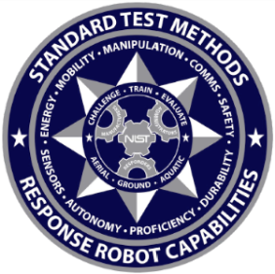
This UAS proficiency course ensures that all department Remote Pilots in Command (RPIC) have the skills necessary to safely operate a UAS at night.
This proficiency course is based on the National Institute of Standards and Technology (NIST) Guide to Measuring and Comparing UAS Capabilities and Remote Pilot Proficiencies Using Standard Test Methods.
The course is untimed and RPIC’s can retest on any areas they do not successfully complete the first time.
Inside each bucket is an inscribed ring to evaluate alignment. Center targets can be letters, visual/color/thermal, acuity charts, hazmat labels, or other items.
For proficiency testing objectives based on the NFPA standards for public safety UAS, see Curriculum Objectives.

Documentation
Use the PSURT UAS RPIC Level 1 Checklist to qualify the student. After a successful test, complete the PSURT RPIC Certification Form which both you and the student must sign. Send a copy of both forms to the student’s department.
For examples of forms, see Appendix A: Form Examples. The forms are included with the PSURT program.

Skills Evaluated
Hold Position and Altitude | Establish and hold a hover position and orientation
Orbit a Point | Move position and rotate around a point
Fly Straight and Level | Fly straight and level for short distances
Identify and Inspect Objects | Move and rotate around an object of interest to identify key features and inspect key details from close proximity
Land Accuracy | Land accurately from vertical and downward 90-degree descending approaches
In order to count an observation successful, a RPIC must view the entire ring inside each bucket. If any portion of the ring is obscured, they should maneuver their aircraft until the entire ring is in view before moving on to the next bucket.
X
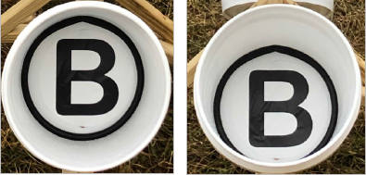

Course Setup
For information, see Appendix B: Building the UAS Proficiency Course.

Position (Maneuvering 1)
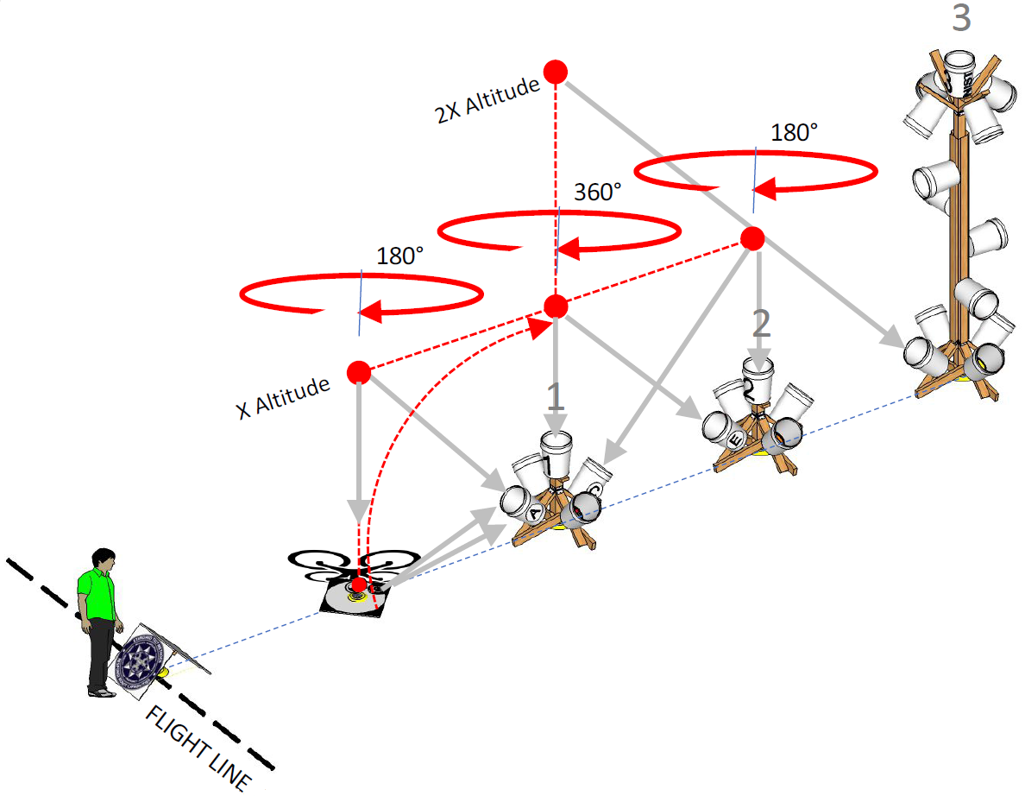
Task # | Maneuver | Locate
1 | Launch to 10ft and hover over Stand #1 | 1 & 2E
2 | Rotate right 360° over Stand #1 | 1 & 2E
3 | Rotate left 360° over Stand #1 | 1 & 2E
4 | Climb to 20ft over Stand #1 | 1 & 2E
5 | Descend to 10ft over Stand #1 | 1 & 2E
6 | Forward over Stand #2 | 2 & 3I
7 | Backward over Stand #1 | 1 & 2E
8 | Forward over Stand #2 and rotate right 180° | 2 & 1C
9 | Forward over Landing Platform and rotate left 180° | L & 1A
10 | Land centered facing stands

Position (Maneuvering 2)
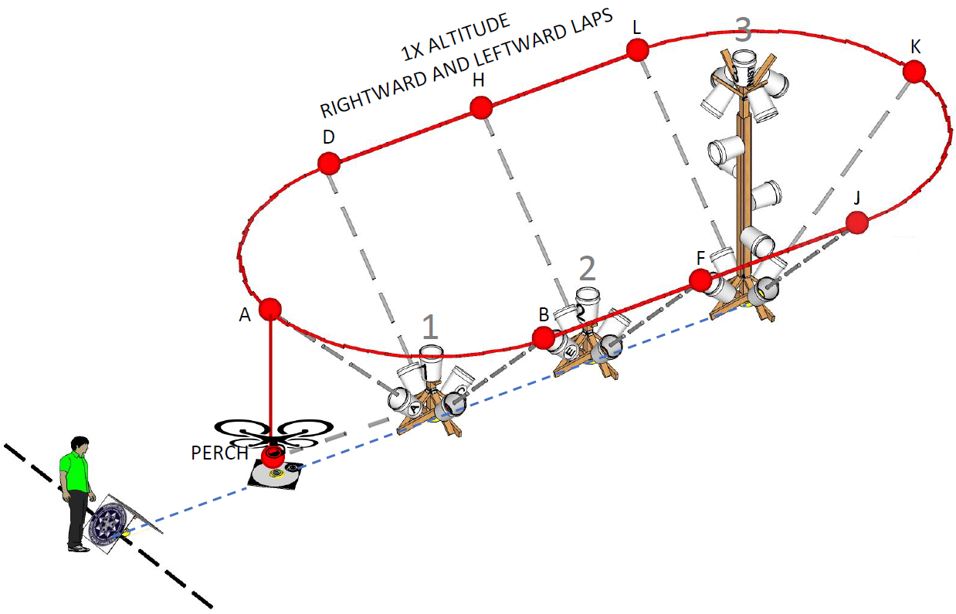
Task # | Maneuver | Locate
11 | Launch to 10ft and hover over Landing Platform | 1A
12 | Traverse right around the training apparatus, pausing directly over each location | 1B
13 | Continue | 2F
14 | Continue | 3J
15 | Continue | 3K
16 | Continue | 3L
17 | Continue | 2H
18 | Continue | 1D
19 | Continue | 1A
20 | Land centered facing stands
21 | Launch to 10ft and hover over Landing Platform | 1A
22 | Traverse left around the training apparatus, pausing directly over each location | 1D
23 | Continue | 2H
24 | Continue | 3L
25 | Continue | 3K
26 | Continue | 3J
27 | Continue | 2F
28 | Continue | 1B
29 | Continue | 1A
30 | Land centered facing stands

Curriculum Objectives
The National Fire Protection Association has developed standards for public safety UAS that include aerial test methods developed by NIST that measure the capabilities of the UAS as well as the proficiency of the RPIC. These curriculum objectives are based on the NFPA standards.
GENERAL OBJECTIVES
1. | The flight team members shall demonstrate a basic knowledge of laws, rules, regulations, statutes, and case laws that impact public safety UAS operations.
2. | The RPIC shall demonstrate a complete preflight inspection of the aircraft and determine the airworthiness of the aircraft.
3. | The RPIC shall select proper software systems for the given mission.
4. | The RPIC shall properly identify all flight hazards within the designated flight area.
5. | The RPIC shall develop a flight plan which identifies each role of the flight team, common procedures, emergency procedures, and any hazards located within the mission area.
6. | The RPIC shall communicate any deviations from the flight plan to their flight team.
7. | The RPIC shall maintain safe flight rules, ensuring proper spacing in altitude and communication of actions with other RPIC’s.
8. | The RPIC shall properly demonstrate the concept of overwatch and coordination of the mission.
9. | The RPIC shall demonstrate the ability to properly adjust camera settings to obtain useable media.
10. | All Visual Observers shall demonstrate the ability to access systems to properly monitor the mission for safety, and to assist in identifying targets using the first-person view.
11. | All flight team members shall demonstrate the proper use of communications equipment.
12. | The RPIC shall demonstrate the ability to safely return the aircraft to the home point and land without damage.

SEARCH AND IDENTIFY SCENARIO OBJECTIVES |  |  | SEARCH AND RESCUE SCENARIO OBJECTIVES
1. | The RPIC shall locate and identify the suspect vehicle while using first person view. |  | 1. | The RPIC shall demonstrate their knowledge of different search patterns for search and rescue.
2. | The RPIC shall properly document the location of the suspect vehicle using available information. |  | 2. | The RPIC shall demonstrate knowledge of weather, terrain, and other conditions that may affect the chosen search patterns.
3. | The RPIC shall identify any evidence and its location along the path the suspect vehicle took while using first person view. |  | 3. | The RPIC shall demonstrate their ability to read and communicate GPS coordinates.

BARRICADED SUSPECT SCENARIO OBJECTIVES |  |  | MAPPING / PHOTOGRAMMETRY SCENARIO OBJECTIVES
1. | The RPIC shall demonstrate the ability to identify all exits of a building while using first person view. |  | 1. | The RPIC shall prepare an automated flight plan to ensure proper documentation of the designated area.
2. | The RPIC shall demonstrate the ability to search the outside of a building for hazards, including suspects, using first person view. |  | 2. | The RPIC shall demonstrate the ability to fly an automated flight plan.

OVERWATCH / INDOOR SCENARIO OBJECTIVES |  |  | MISSION PLANNING OBJECTIVES
1. | The RPIC shall demonstrate the ability to conduct an interior search of a building using a first-person view for a suspect or evidence. |  | 1. | The RPIC shall demonstrate the knowledge of basic applications that provide weather and airspace information for the flight area.
2. | The RPIC shall demonstrate their knowledge of obstacles and hazards found with interior UAS flight. |  | 2. | The RPIC shall demonstrate the knowledge of how weather conditions can affect the mission.
3. | The RPIC shall demonstrate the ability to control an aircraft while entering and exiting a building through openings of differing sizes. |  | 3. | The RPIC shall demonstrate knowledge of limitations found within the applications they choose.
4. | The RPIC shall demonstrate the ability to properly adjust camera settings to improve vision without the use of auxiliary lighting. |  | 4. | The RPIC shall demonstrate the ability to perform a compass calibration.
 |  |  | 5. | The RPIC shall demonstrate the ability to file a NOTAM and confirm that it is properly published.
 |  |  | 6. | The RPIC shall demonstrate the ability to check pertinent NOTAMs for the mission area.

IN-FLIGHT EMERGENCY RESPONSE OBJECTIVES |  |  | PROFICIENCY TESTING OBJECTIVES
1. | The RPIC shall demonstrate their ability to respond to a flight display failure. |  | The RPIC shall demonstrate the following skills based on the National Institute of Standards and Technology (NIST) Remote Pilot Proficiencies:
2. | The RPIC shall demonstrate their ability to respond to a flight display cable failure. |  | 1. | Hold position and altitude.
3. | The RPIC shall demonstrate their ability to respond to a loss of sight of the UAS. |  | 2. | Orbit a point while aligning the aircraft toward the target.
4. | The RPIC shall demonstrate their ability to respond to a loss of video link. |  | 3. | Fly straight and level.
5. | The RPIC shall demonstrate their ability to respond to a loss of telemetry. |  | 4. | Inspect objects by maneuvering the aircraft safely close to the target while properly manipulating the camera system.
6. | The RPIC shall demonstrate their ability to respond to a loss of aircraft position. |  | 5. | Identify objects.
 |  |  | 6. | Avoid obstacles while maneuvering the aircraft in different orientations through the flight.
 |  |  | 7. | Land accurately.

Appendix A: Form Examples

PSURT UAS RPIC Level 1 Checklist
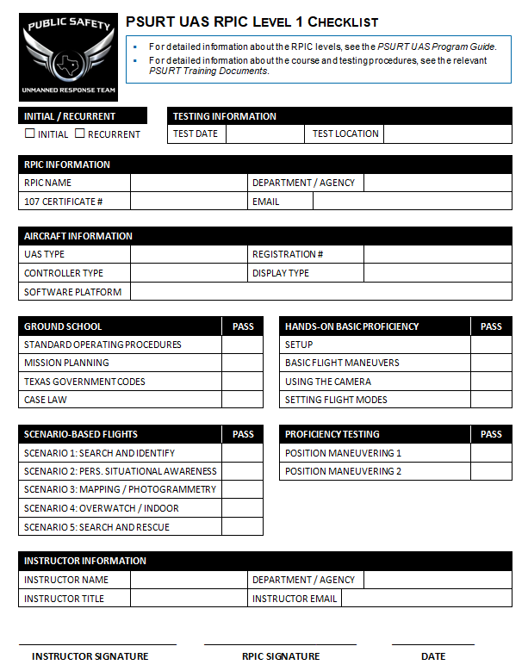

PSURT UAS RPIC Certification Form
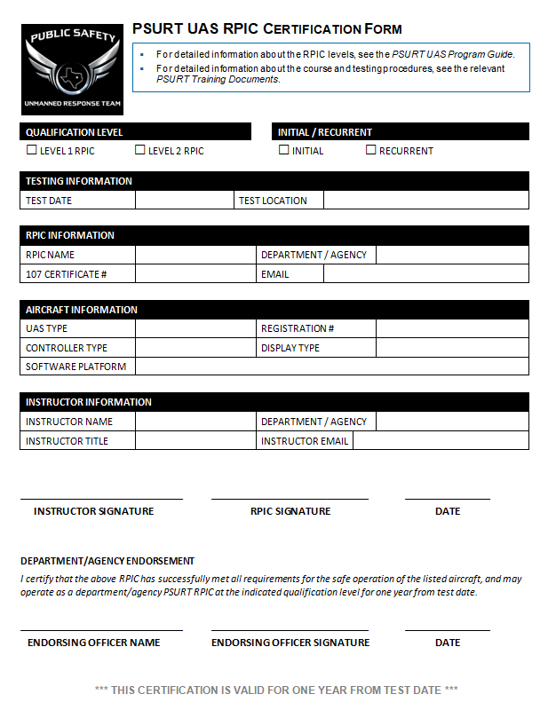

PSURT UAS Course Evaluation Form
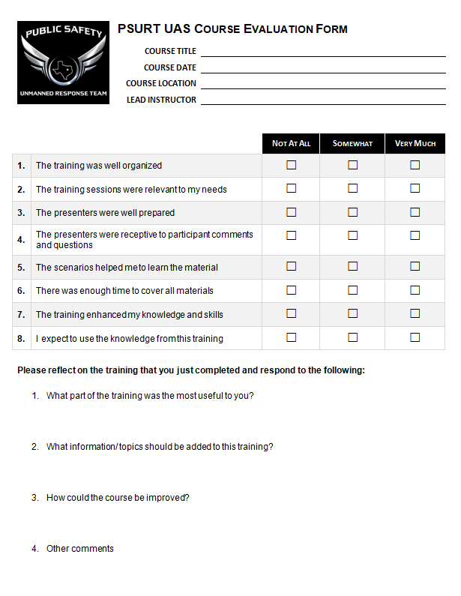

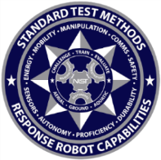
Appendix B: Building the UAS Proficiency Course
The proficiency course is based on the National Institute of Standards and Technology (NIST) Guide to Measuring and Comparing UAS Capabilities and Remote Pilot Proficiencies Using Standard Test Methods.
For information about the NIST course, and for detailed setup steps, including printable stickers, see the NIST Standard Test Methods for sUAS_v20190905.pdf that is included with this program.
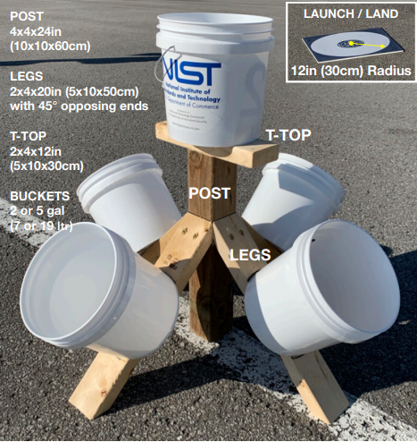
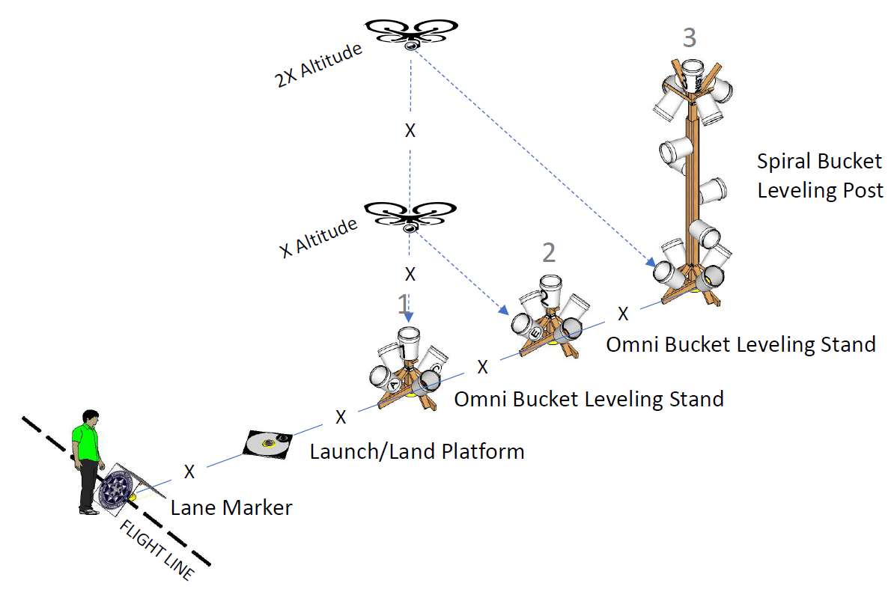
Setup Options
Depending on the tests that you want to use, there are two options for building your test lane:
- Two Omni bucket levelling stands + one Spiral bucket leveling post, or
- Three Omni bucket levelling stands

Lane Features
- Pilot flight line for safety (A-frame as lane marker).
- Centerline using 100ft (30m) measuring tape.
- Launch/Land platform to measure accuracy.
- Bucket stands with vertical and angled white buckets that can be stowed and transported
- Optional outriggers that enable bucket stands to be leveled on uneven terrain
- Apparatus spacing is 10ft (3m)
- Flight altitudes are 10ft (3m) and 20ft (6m)
- Overall length is 50ft (15m)
Supplies
3 bucket stands and 1 launch/land platform panel.
Note: The supplies listed below are for three of the short stands. They do not include the spiral bucket leveling post (tall stand).
Quantity | Item
3 | 4x4x24in posts
12 | 2x4x20in legs, 45deg cuts both ends opposing
3 | 2x4x12in T-tops
12 | 2x2x24in or 2x4x24in outriggers (uneven terrain)
100 | 3-1/in washer head screws to secure lumber joints
15 | Bolts with wing nuts to secure buckets, allowing buckets to be easily removed
15 | 2 or 5 gallon white buckets
1 | Launch/Land platform panel with 12in radius circle
1 | 100ft measuring tape as center line
1 | Post level to measure vertical
1 | Thick black marker to inscribe 1in (25mm) rings inside buckets and write letters inside and out. Or 8in (200mm) round white polyester weatherproof labels can be printed from the QUICK START GUIDE downloadable from www.RobotTestMethods.nist.gov Aerial Systems web page.

Appendix C: Flight Hand Signals
