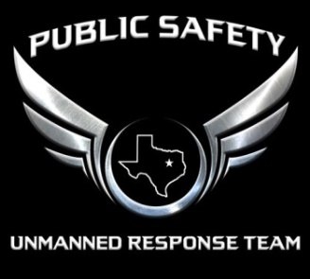
PSURT UAS Visual Observer Course Quiz
VO NAME
DATE
LOCATION

1. |  | True / False: Conducting a daytime flight under Visual Flight Rules means staying below 400’ AGL, having a 3 mile minimum visibility, and a cloud ceiling at least 500 feet above flight altitude.
2. |  | Correction of Autokinesis can be done by which of the following?  - Focusing eyes at varying distances  - Increasing speed of visual scanning  - Increasing your eye rate of blinking  - A and B only
3. |  | True / False: A VO may use binoculars or other similar equipment to maintain VLOS.
4. |  | Under Part 107, maximum allowable speed is:  - 100 knotts per hour  - 87 knotts per hour  - 100 miles per hour  - Both B and C
5. |  | True / False: If both the RPIC and VO lose VLOS of the UAS, the RPIC must land the UAS immediately.
6. |  | True / False: You may not fly during civil twilight without a waiver.
7. |  | What do you lose when you are exposed to excessively bright light?  - Contrast discrimination  - Depth perception  - Visual reaction time  - All of the above
8. |  | True / False: A VO is optional but highly recommended for daytime and nighttime missions.
9. |  | Reversible Perspective Illusion can be eliminated by which of the following?  - Comparing the possible moving light to a fixed light on the surface.  - Reversible Perspective Illusion cannot be corrected so the mission must be terminated  - Looking away from the aircraft lights to regain night vision  - None of the above
10. |  | True / False: The VO should constantly scan the skies and the ground to identify potential hazards and notify the RPIC of those hazards as they arise.

