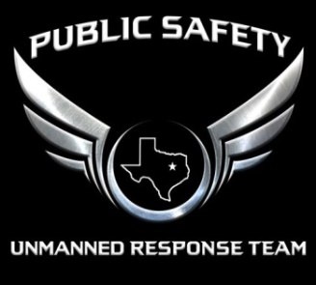
PSURT UAS RPIC/VO Night Mission Pre-Flight Quiz
RPIC/VO NAME
DATE
LOCATION

1. |  | True / False: Autokinesis is caused by staring at single points of light for more than a few seconds. The lights then appear to move even if the aircraft is not moving.
2. |  | Correction of Autokinesis can be done by which of the following?  - Focusing eyes at varying distances  - Increasing speed of visual scanning  - Increasing your eye rate of blinking  - A and B only
3. |  | True / False: Reversible Perspective Illusion occurs when an aircraft may look like it's moving away from you, but it's actually moving towards you.
4. |  | Reversible Perspective Illusion can be eliminated by which of the following?  - Comparing the possible moving light to a fixed light on the surface.  - Reversible Perspective Illusion cannot be corrected so the mission must be terminated  - Looking away from the aircraft lights to regain night vision  - None of the above
5. |  | True / False: Size and Distance Illusion occurs when a light is slowly pulsing, creating a false impression of approaching or receding aircraft.
6. |  | True / False: Fascination is becoming fixated on one particular subject and not paying attention to surroundings.
7. |  | What do you lose when you are exposed to excessively bright light?  - Contrast discrimination  - Depth perception  - Visual reaction time  - All of the above
8. |  | True / False: Flicker Vertigo is when the lighting cycle causes nausea or dizziness.
9. |  | Which of the following may be other issues that can affect the flight team during night operations?  - Loss of night vision  - Inability to focus on a subject  - Dehydration  - All of the above are concerns for night operations
10. |  | True / False: Rest and Nutrition can improve your night vision.

