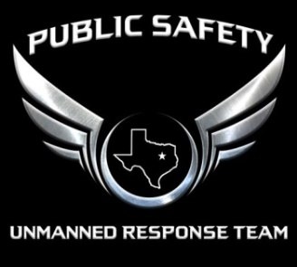
PSURT UAS RPIC Level 2 Checklist
- For detailed information about the levels, see the PSURT UAS Program Guide.
- For detailed information about the course and testing procedures, see the relevant PSURT Training Documents.
INITIAL / RECURRENT |  | TESTING INFORMATION
INITIAL RECURRENT | TEST DATE |  | TEST LOCATION

RPIC INFORMATION
RPIC NAME |  | DEPARTMENT / AGENCY
107 CERTIFICATE # |  | EMAIL

AIRCRAFT INFORMATION
UAS TYPE |  | REGISTRATION #
CONTROLLER TYPE |  | DISPLAY TYPE
SOFTWARE PLATFORM

GROUND SCHOOL | PASS |  | HANDS-ON BASIC PROFICIENCY | PASS
UAS NIGHT OPERATIONS |  |  | SETUP
HOW THE EYE WORKS |  |  | BASIC FLIGHT MANEUVERS
SPATIAL DISORIENTATION / VISUAL ILLUSIONS |  |  | USING THE CAMERA
IMPROVING YOUR NIGHT VISION |  |  | SETTING FLIGHT MODES
THERMOGRAPHICS

SCENARIO-BASED FLIGHTS | PASS |  | PROFICIENCY TESTING | PASS
SCENARIO 1: SEARCH AND IDENTIFY |  |  | POSITION MANEUVERING 1
SCENARIO 2: SEARCH AND RESCUE |  |  | POSITION MANEUVERING 2
SCENARIO 3: TRACK SUSPECT

INSTRUCTOR INFORMATION
INSTRUCTOR NAME |  | DEPARTMENT / AGENCY
INSTRUCTOR TITLE |  | INSTRUCTOR EMAIL

_______________________________ ______________________________ ________________
INSTRUCTOR SIGNATURE RPIC SIGNATURE DATE

