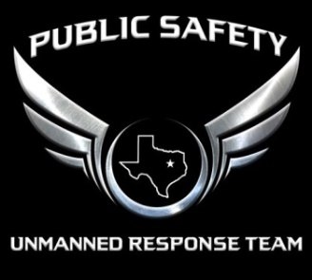
PSURT UAS RPIC Level 1 Checklist
- For detailed information about the RPIC levels, see the PSURT UAS Program Guide.
- For detailed information about the course and testing procedures, see the relevant PSURT Training Documents.
INITIAL / RECURRENT |  | TESTING INFORMATION
INITIAL RECURRENT | TEST DATE |  | TEST LOCATION

RPIC INFORMATION
RPIC NAME |  | DEPARTMENT / AGENCY
107 CERTIFICATE # |  | EMAIL

AIRCRAFT INFORMATION
UAS TYPE |  | REGISTRATION #
CONTROLLER TYPE |  | DISPLAY TYPE
SOFTWARE PLATFORM

GROUND SCHOOL | PASS |  | HANDS-ON BASIC PROFICIENCY | PASS
STANDARD OPERATING PROCEDURES |  |  | SETUP
MISSION PLANNING |  |  | BASIC FLIGHT MANEUVERS
TEXAS GOVERNMENT CODES |  |  | USING THE CAMERA
CASE LAW |  |  | SETTING FLIGHT MODES

SCENARIO-BASED FLIGHTS | PASS |  | PROFICIENCY TESTING | PASS
SCENARIO 1: SEARCH AND IDENTIFY |  |  | POSITION MANEUVERING 1
SCENARIO 2: PERS. SITUATIONAL AWARENESS |  |  | POSITION MANEUVERING 2
SCENARIO 3: MAPPING / PHOTOGRAMMETRY
SCENARIO 4: OVERWATCH / INDOOR
SCENARIO 5: SEARCH AND RESCUE

INSTRUCTOR INFORMATION
INSTRUCTOR NAME |  | DEPARTMENT / AGENCY
INSTRUCTOR TITLE |  | INSTRUCTOR EMAIL

_______________________________ ______________________________ ________________
INSTRUCTOR SIGNATURE RPIC SIGNATURE DATE

