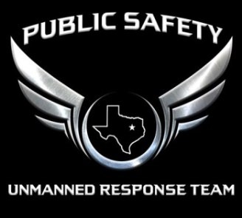
PSURT UAS Course Evaluation Form
COURSE TITLE
COURSE DATE
COURSE LOCATION
LEAD INSTRUCTOR

 |  | Not At All | Somewhat | Very Much
1. | The training was well organized
2. | The training sessions were relevant to my needs
3. | The presenters were well prepared
4. | The presenters were receptive to participant comments and questions
5. | The scenarios helped me to learn the material
6. | There was enough time to cover all materials
7. | The training enhanced my knowledge and skills
8. | I expect to use the knowledge from this training

Please reflect on the training that you just completed and respond to the following:

- What part of the training was the most useful to you?

- What information/ topics should be added to this training?

- How could the course be improved?

- Other comments

