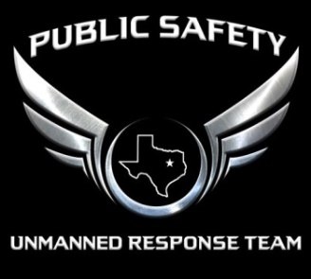
PSURT UAS RPIC Certification Form
- For detailed information about the RPIC levels, see the PSURT UAS Program Guide.
- For detailed information about the course and testing procedures, see the relevant PSURT Training Documents.

QUALIFICATION LEVEL |  | INITIAL / RECURRENT
LEVEL 1 RPIC LEVEL 2 RPIC | INITIAL RECURRENT

TESTING INFORMATION
TEST DATE |  | TEST LOCATION

RPIC INFORMATION
RPIC NAME |  | DEPARTMENT / AGENCY
107 CERTIFICATE # |  | EMAIL

AIRCRAFT INFORMATION
UAS TYPE |  | REGISTRATION #
CONTROLLER TYPE |  | DISPLAY TYPE
SOFTWARE PLATFORM

INSTRUCTOR INFORMATION
INSTRUCTOR NAME |  | DEPARTMENT / AGENCY
INSTRUCTOR TITLE |  | INSTRUCTOR EMAIL

_______________________________ ______________________________ ________________
INSTRUCTOR SIGNATURE RPIC SIGNATURE DATE

DEPARTMENT/AGENCY ENDORSEMENT
I certify that the above RPIC has successfully met all requirements for the safe operation of the listed aircraft, and may operate as a department/agency PSURT RPIC at the indicated qualification level for one year from test date.

_______________________________ ______________________________ ________________
ENDORSING OFFICER NAME ENDORSING OFFICER SIGNATURE DATE

